Final Project Marketing Strategy Due: ‘Audi on Demand Travel Experience Business Idea’

TABLE OF CONTENTS

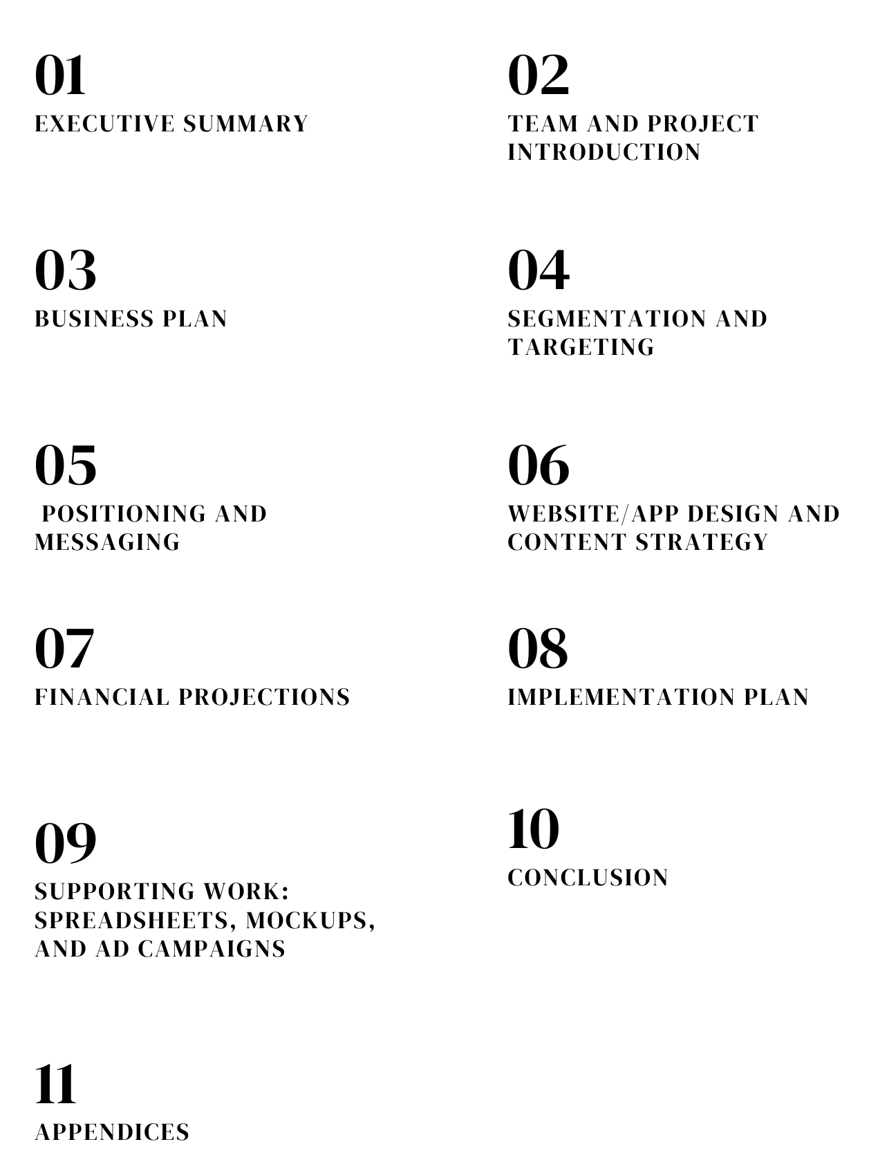

- EXECUTIVE SUMMARY
The Audi On Demand Travel Experience combines Audi's premium fleet with curated travel packages to redefine luxury road trips. Designed for adventure seekers, family vacationers, and luxury travelers, the program delivers seamless booking, premium accommodations, and exclusive itineraries through an integrated website and app. Key focus areas include iconic destinations like the Finger Lakes, Catskills, and Hudson Valley, offering stress-free and unforgettable journeys tailored to discerning customers.
The initiative aims to launch by June 1, 2025, secure partnerships with over 50 upscale hotels and travel providers, and achieve $5 million in revenue within the first year. To drive adoption and awareness, a multi-channel marketing strategy leveraging social media, influencer collaborations, and content marketing will be implemented. Financial projections estimate a strong 266% return on investment (ROI) in Year 1, strengthening Audi's position as a leader in luxury travel, enhancing brand loyalty, and unlocking new revenue streams.

- PROJECT INTRODUCTION

Why Audi on Demand Travel Experience?
- Unrivaled Comfort and Luxury: For both business workers and vacationers, Audi on Demand provides access to a first-rate fleet of luxury cars with unmatched comfort and style. From sporty sedans to roomy SUVs, Audi's dedication to quality elevates every trip.

- Selected Vacation Packages: The website offers customized travel experiences, such as self-drive excursions, guided tours, and scenic drives. These packages are made to accommodate the individual tastes of each tourist, providing enjoyable and stress-free trips.

- Special Benefits for New Users: Experience the premium services offered by Audi on Demand more easily by taking advantage of special offers for first-time users, such as discounts and upgrades.
- Smooth Reservation Process: Audi on Demand guarantees a hassle-free booking experience with its secure payment choices and easy-to-use navigation. Users may easily explore packages, reserve cars, and personalize their experiences on the website.

- Reliable Service with Round-the-Clock Help: Audi on Demand is recognized for its reliability and premium customer support. With round-the-clock support and an emphasis on client satisfaction, travelers can plan their trips with confidence.

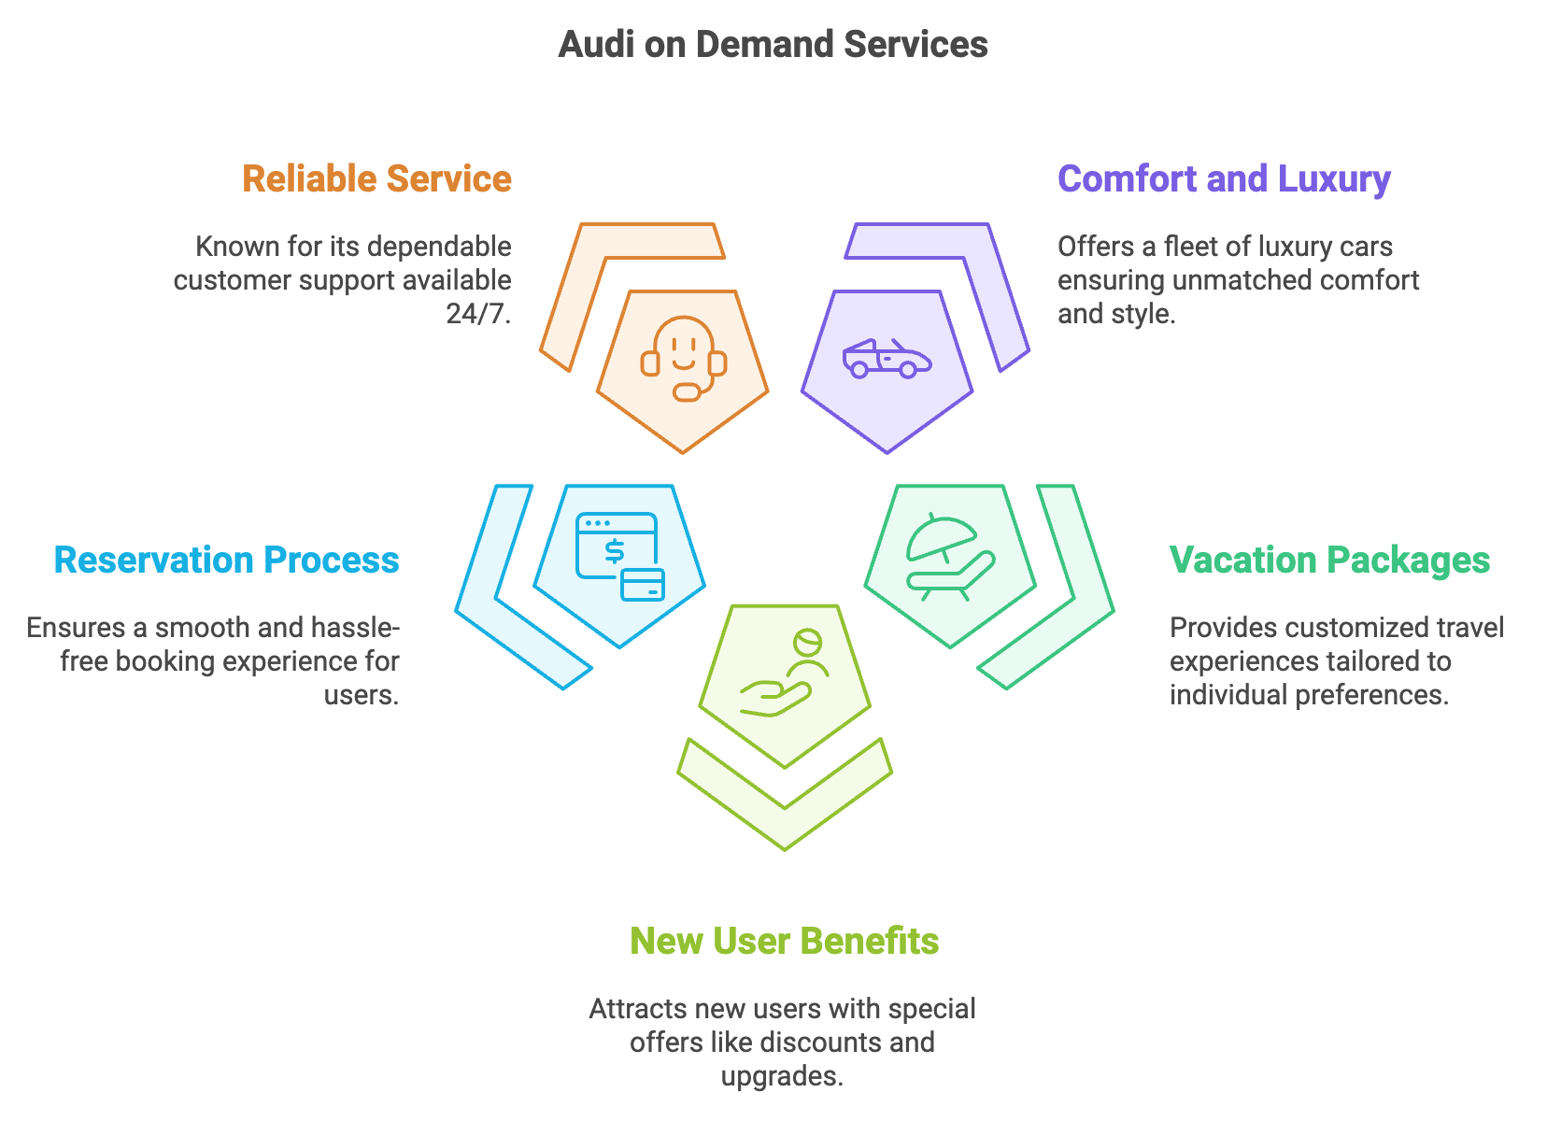
Fig 1: Audi on Demand Services
The Audi on Demand Travel Experience is the best option for discriminating tourists since it blends elegance, practicality, and personalization.
This initiative envisions curated travel packages that combine:
- Scenic Drives: renowned roads with stunning scenery that are tailored for Audi automobiles.
- Premium Lodging: Collaborations with upscale resorts and hotels to guarantee opulent stays.
- Customized Itineraries: Adventure and leisure-oriented choices to accommodate a range of client tastes.

Purpose of the Initiative:
- Brand Differentiation: Strengthening Audi’s brand image as a pioneer in luxury experiences.
- Revenue Diversification: Introducing a new revenue stream that complements existing services.
- Customer Loyalty: Building deeper connections with Audi’s high-value customers.

2.3 Objectives:
The following are the specific objectives of the Audi On Demand Travel Experience initiative:
- By June 1, 2025, the platform should be launched: Create and incorporate the Audi On Demand website and app's travel booking functionality.
- By Year 1, collaborate with more than 50 upscale travel and hotel companies: Work together with upscale lodging establishments, travel agencies, and tourism boards to guarantee a variety of options.
- Within the first 12 months, generate $5 million in revenue: Prioritize early adopter incentives, special discounts, and targeted marketing.

2.4 Timeline and Milestones:

The project adheres to a planned schedule to guarantee on-time completion:

Phase 1: Preparation (Jan–Mar 2025)
- Partner with hotels and tour operators in Hudson Valley, Catskills, and Hamptons.
- Develop and test the travel booking platform.
- Finalize pricing for adventure and luxury packages.

Phase 2: Start-up (Apr-Jun 2025)
- Launch the platform on June 1, 2025, with a New York event.
- Pilot packages in regional destinations.
- Offer early adopter discounts.

Phase 3: Optimization (Jul–Dec 2025)
- Collect feedback through surveys and reviews.
- Refine pricing and packages based on customer input.
- Expand to East Coast cities like Boston and Philadelphia.

BUSINESS PLAN

3.1 Core Business Strategy:
The Audi on Demand Travel Experience combines carefully chosen travel options with Audi's renowned luxury automobiles to produce one-of-a-kind and unforgettable experiences. The campaign targets wealthy tourists looking for upscale and customized travel options by utilizing Audi's strong brand identification.

Strategic Foundations:

- Partnerships: To develop unique packages, and work with upscale hotel chains, travel agencies, and tourism boards.
- Technology Integration: Create a user-friendly infrastructure that enables smooth booking through the Audi On Demand website and app.
- Customer-Centric Approach: Make sure that Audi's dedication to quality is shown in every encounter, from the reservation to the trip.

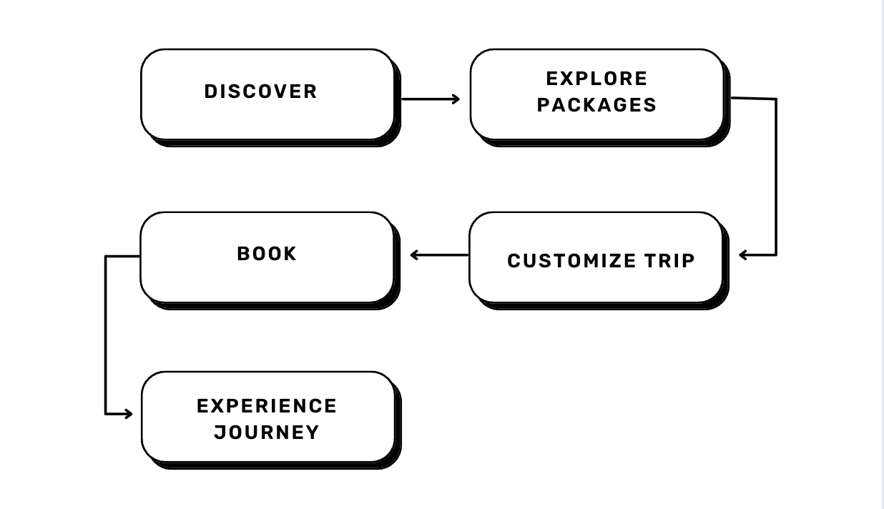
Fig 2: Representation of how the strategy aligns with the customer journey

3.2 Product Offerings:
The Audi on Demand Travel Experience offers two main package options designed to meet the various needs of its clients:

3.2.1. Large Audi Fleet
Description: Experience the ultimate in luxury and performance with Audi’s diverse fleet. Whether you’re a corporate professional, a travel enthusiast, or planning a family trip, we have the perfect Audi for you.
Examples:
- Premium Sedans: Audi A6 or A8 for business professionals.
- Spacious SUVs: Audi Q7 or Q8 for family or group adventures.
- High-Performance Sports Cars: Audi R8 for thrill-seekers.
Key Features:
- Advanced driver-assist technology for safety and comfort.
- Luxurious interiors with premium finishes.
- Seamless smartphone integration for navigation and entertainment.
- Eco-friendly hybrid and electric vehicle options.

3.2.2. Travel Packages
Description: Explore unique destinations with curated travel packages designed for every type of explorer. Audi’s Travel Packages combine luxury and adventure for a memorable journey.
Examples:
- Scenic Drives: A luxurious drive through the Hudson Valley, featuring wineries and historic sites.
- Guided Tours: Explore the Finger Lakes with a personal guide, highlighting scenic trails and local wineries.
- Self-Drive Excursions: A customizable road trip in the Catskills, including suggested stops at lodges and adventure activities.
Key Features:
- Pre-planned itineraries for convenience and flexibility.
- Customizable options to suit personal preferences.
- Recommendations for premium dining, lodging, and activities.
- Dedicated support for on-the-go assistance.

3.2.3. First-Time User Offers
Description: Get the red carpet treatment on your first booking with Audi on Demand. Our exclusive offers make your first journey unforgettable.
Examples:
- 15% Discount: Save on your first luxury Audi booking, whether it’s for a weekend getaway or a business trip.
- Complimentary Upgrades: Upgrade to a premium model for your first trip at no extra cost.
- Special Perks: Early check-ins and late returns for first-time users.
Key Features:
- Hassle-free onboarding and booking process.
- Exclusive promotions to encourage first-time bookings.
- Personalized welcome experiences tailored to your preferences.
- Dedicated customer support to ensure a seamless experience.

3.3 Pricing Strategy

The value-based pricing strategy used by the Audi on Demand Travel Experience is thoughtfully designed to match the high caliber of its products. This tactic makes sure that the price reflects the exclusivity, luxury, and convenience that customers anticipate. A thorough explanation of the pricing strategy is provided below:

3.3.1. High-end prices for luxury cars
The Audi on Demand Travel Experience employs a carefully crafted value-based pricing strategy that reflects the premium nature of its offerings. This strategy ensures that the pricing aligns with customer expectations of luxury, convenience, and exclusivity. Below is a detailed breakdown of the pricing approach:

3.3.1. Premium Pricing for Luxury Vehicles
- High-End Positioning: The pricing structure highlights the premium quality of Audi’s fleet, reinforcing its luxury brand image. Customers pay for exclusivity, advanced features, and unmatched comfort.
- Pricing for Value:
  - Daily Rentals: Starting at $199 for entry-level vehicles ensures affordability without compromising on the luxury image.
  - Premium Models: Pricing scales for high-performance vehicles like the Audi R8 or Audi A8, targeting affluent customers.
- Segment-Based Pricing:
  - Sedans for corporate professionals at competitive rates.
  - Spacious SUVs for families and groups at mid-tier pricing.
  - High-performance sports cars at premium rates for adventure enthusiasts.
3.3.2. Competitive Package Pricing
- Bundled Value: Travel packages combine the rental of luxury vehicles with additional experiences, such as scenic drives, guided tours, or self-drive itineraries. This creates a compelling value proposition for customers.
- Pricing Tiers:
  - Scenic Drives: Affordable options for travelers seeking memorable road trips.
  - Guided Tours: Mid-tier pricing for all-inclusive packages featuring expert guides.
  - Custom Self-Drive Excursions: Premium pricing for personalized itineraries and add-ons such as luxury lodging and exclusive dining experiences.
- Examples:
  - A scenic drive through the Hudson Valley starting at $500, including a luxury vehicle for two days and recommended stops.
  - A custom Finger Lakes tour priced at $1,200 with lodging and guided wine tastings.

3.3.3. First-Time User Discounts
- Objective: Encourage new customers to experience Audi on Demand by reducing the barrier to entry.
- Special Offers:
  - Discounts like 25% off the first booking or $199 starting packages incentivize customers to try the service.
  - Complimentary perks, such as vehicle upgrades or additional free miles, add value to the initial experience.
- Customer Conversion: The focus is on converting first-time users into loyal, repeat customers through exceptional service and pricing incentives.
3.3.4.Seasonal Promotions and Limited-Time Offers
- Time-Sensitive Deals: The website features promotions such as “25% off your first booking” valid until December 31.
- Peak Season Pricing: Audi on Demand likely adjusts pricing during high-demand periods, such as holidays and summer vacations, to capitalize on increased travel activity.
- Examples:
  - Winter holiday specials offering discounted rates for mountain trips in the Adirondacks.
  - Summer promotions for coastal drives, encouraging road trips to the Finger Lakes.

3.4 Place (Distribution Strategy)
Audi’s distribution strategy ensures accessibility and convenience for customers:

3.4.1 Website/App Integration
The Audi On Demand platform will serve as the primary booking hub, offering:
- Filters for destinations, trip duration, and package type.
- Real-time customization and availability updates.
- Secure payment options for seamless transactions.

3.4.2 Offline Integration
Audi dealerships will complement the online platform by:
- Promoting travel packages through in-store displays.
- Offering exclusive discounts to loyal Audi customers.
(Platform Screenshot Mockup)

3.5 Promotion Strategy
Audi will employ a multi-channel approach to reach its target audience:

3.5.1 Digital Advertising
- SEM: Target keywords like “luxury self-drive tours.”
- Social Media Ads: Showcase travel experiences on Instagram, Facebook, and YouTube.
- Influencer Marketing: Partner with travel influencers for authentic endorsements.

3.5.2 Content Marketing
- Blog Posts: Topics like “Top Scenic Routes in the Catskills with Audi”.
- Videos: Short clips of Audi vehicles on iconic routes, emphasizing luxury and adventure.

3.5.3 Partnerships and Co-Marketing
- Collaborate with tourism boards to promote destinations.
- Offer exclusive deals with lodging and tour operators.
3.6 Situation Analysis:
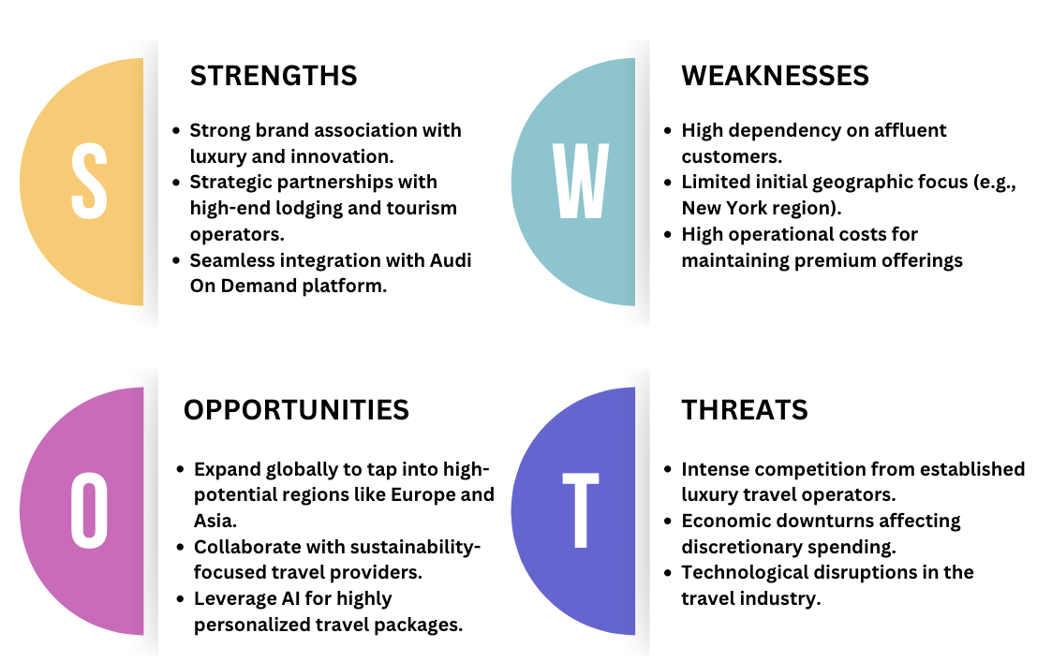
Fig 3: SWOT Analysis
3.7 Marketing Budget Allocation:
- SEM (40%) - $500,000
- Objective: Drive targeted traffic to the platform by leveraging search engine marketing and optimizing organic search visibility.
- Key Activities:
  - Paid search ads targeting keywords such as “luxury travel NY” and “scenic drives.”
  - Ongoing SEO optimization for the Audi On Demand platform.
  - Blog content to improve rankings for travel-related searches.
- Social Media Advertising (30%) - $375,000
- Objective: Build brand awareness and engage with a younger, tech-savvy audience through visually driven campaigns.
- Key Activities:
  - Instagram and TikTok ads showcasing scenic drives, luxury stays, and curated packages.
  - User-generated content campaigns to increase organic engagement.
  - Targeted Facebook ads for affluent travelers and families.
- Influencer Marketing (20%) - $250,000
- Objective: Enhance credibility and visibility by collaborating with travel and luxury influencers.
- Key Activities:
  - Partner with top travel influencers to promote Audi packages through authentic storytelling.
  - Host influencer experiences to showcase Adventure and Luxury packages in key destinations (e.g., Hudson Valley, Catskills, Hamptons).
- Other Channels (10%) - $125,000
- Objective: Support complementary marketing efforts to maintain engagement and loyalty.
- Key Activities:
  - Personalized email campaigns offering exclusive discounts for early adopters.
  - PR campaigns to secure media coverage in luxury travel and automotive publications.

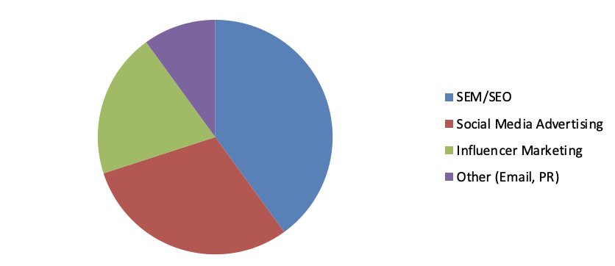
Fig 4: Marketing Budget Allocation

- SEGMENTATION AND TARGETING

4.1 Geographic Segmentation:
The Audi on Demand Travel Experience follows the pilot's focus on the New York market by targeting people who live in or are visiting New York City and the surrounding areas.
Target Locations:
- New York City: Central hub for affluent travelers and urban professionals.
- Hudson Valley: Known for scenic drives, wineries, and farm-to-table dining.
- Catskills: Offers adventure activities like hiking and skiing.
- Adirondacks: A destination for nature lovers, with pristine lakes and forests.
- Finger Lakes: Famous for wine trails and serene landscapes
(Heat Map Visuals)

4.2. Demographic Segmentation
Audi 360 segments its audience into three primary groups based on age, income, and lifestyle preferences:
- Adventure Seekers/First Time Users:
  - Age: 20–35.
  - Characteristics: Young professionals or students seeking offbeat and flexible travel options.
- Family Tourists:
  - Age: 35–50.
  - Characteristics: Parents or caregivers looking for safe, family-friendly experiences.
- Luxury Travelers:
  - Age: 30–55.
  - Characteristics: High-income individuals seeking premium, elegant travel options.
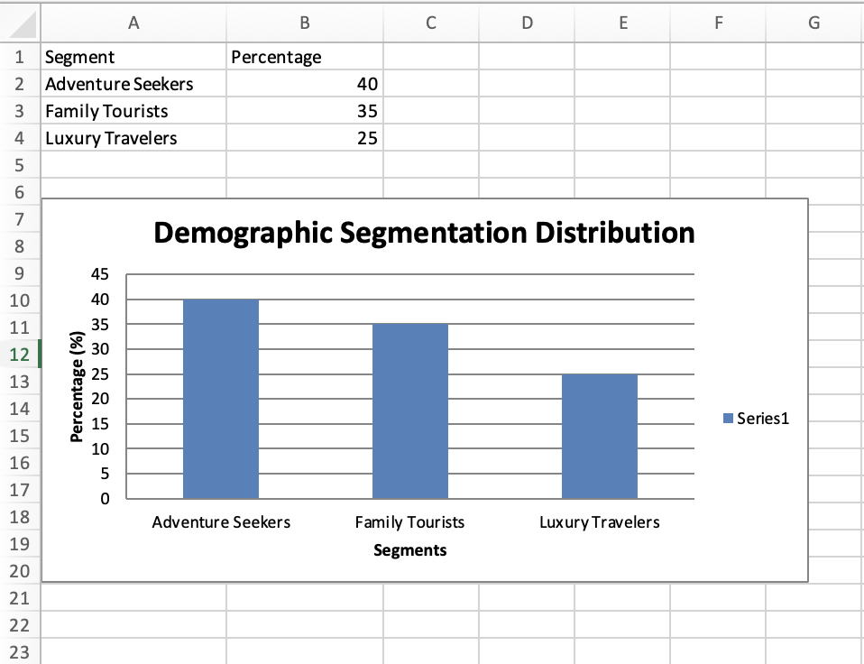
Fig 5: Demographic Segmentation

4.3. Psychographic Segmentation
This segmentation focuses on audience behaviors, preferences, and motivations:
- Adventure Seekers:
  - Profile: Thrill-seekers who value unique and flexible road trips.
  - Motivations: Escape city life, and seek new adventures and experiences.
  - Travel Preferences: Scenic drives, eco-lodges, and outdoor activities like hiking or rafting.
- Family Tourists:
  - Profile: Safety-conscious individuals prefer pre-planned, kid-friendly experiences.
  - Motivations: Create memorable experiences while ensuring comfort for all family members.
  - Travel Preferences: Guided tours, easy-to-access lodging, and child-friendly amenities.
- Luxury Travelers:
  - Profile: Status-driven, seeking exclusivity and comfort.
  - Motivations: Prioritize premium services and curated luxury experiences.
  - Travel Preferences: Five-star hotels, chauffeur-driven itineraries, and personalized experiences.
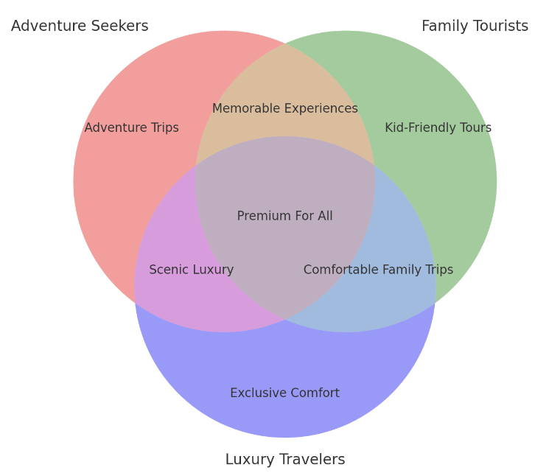
Fig 6: Visual representation of key motivations between the three groups to show shared values like relaxation or adventure.

4.4 Personas:
1. Stefan, The Scenic Wanderer (Adventure Seekers)

- Age: 26
- Job/Industry: Freelance photographer or content creator
- Hobbies: Road trips, camping, and exploring national parks
- Motivations: Finding off-the-beaten-path experiences to capture unique photos and create shareable content
- Travel Preferences:
  - Flexible itineraries with scenic routes
  - Budget-friendly but comfortable eco-lodges
  - Opportunities for adventure activities like kayaking or climbing
- Touchpoints:
  - Instagram hashtags like #RoadTripAdventures
  - Travel YouTube channels and blogs

2. Haley, The Culture Enthusiast (Family Tourists)

- Age: 38
- Job/Industry: Educator or museum curator
- Family Profile: Travels with a partner and two children aged 8 and 12
- Hobbies: Visiting museums, historical sites, and cultural landmarks
- Motivations:
  - Educating their children while bonding as a family
  - Seeking enriching, educational travel experiences
- Travel Preferences:
  - Pre-arranged cultural tours
  - Accommodations with family-friendly amenities
  - Destinations with kid-friendly attractions like science museums or interactive exhibits
- Touchpoints:
  - Parent forums on Facebook
  - TripAdvisor reviews focusing on educational travel

3. Luke, The Business Jetsetter (Luxury Travelers)

- Age: 42
- Job/Industry: Senior executive in finance or technology
- Lifestyle: Prefers seamless travel experiences to maximize productivity during leisure trips
- Motivations:
  - Combines work and leisure (“leisure” trips)
  - Values time efficiency and premium services
- Travel Preferences:
  - Chauffeur-driven cars or self-driven luxury sedans
  - Stays at boutique hotels offering high-speed internet and concierge services
  - Itineraries that include premium dining and networking opportunities
- Touchpoints:
  - LinkedIn for travel inspiration
  - Corporate travel programs and loyalty programs

4. Emily, The Eco Explorer (Adventure Seekers)

- Age: 33
- Job/Industry: Sustainability consultant or environmental activist
- Hobbies: Hiking, wildlife conservation, and volunteering
- Motivations:
  - Minimize their environmental footprint while exploring nature
  - Support eco-friendly travel providers and local communities
- Travel Preferences:
  - Hybrid or electric vehicles for self-drive trips
  - Lodging in eco-lodges or sustainable accommodations
  - Activities like birdwatching or eco-tours
- Touchpoints:
  - Environmental travel blogs
  - Communities on Reddit focusing on sustainable tourism

5. Matty, The Glamorous Globe-Trotter (Luxury Travelers)

- Age: 45
- Job/Industry: Social media influencer or luxury brand consultant
- Lifestyle: Lives for curated luxury experiences and aesthetic perfection
- Motivations:
  - Experiences that elevate their personal brand
  - Exclusive and Instagram-worthy destinations
- Travel Preferences:
  - Exotic destinations with premium lodging
  - Chauffeur-driven Audi vehicles for luxurious transportation
  - Spa experiences and private dining events
- Touchpoints:
  - Instagram collaborations with luxury travel companies
  - Features in high-end travel magazines

6. Ellen, The Weekend Wanderer (Family Tourists)

- Age: 36
- Job/Industry: Marketing manager or small business owner
- Family Profile: Travels with a spouse and one child aged 5
- Hobbies: Weekend road trips, exploring local cuisines, and visiting farms or nature parks
- Motivations:
  - Quick getaways to recharge and spend quality time with family
  - Value-for-money trips that balance comfort and adventure
- Travel Preferences:
  - Short road trips within 2–3 hours of their home
  - Stays at Airbnb-style accommodations with a homely feel
  - Kid-friendly activities like petting zoos or nature trails
- Touchpoints:
  - Parenting blogs for travel tips
  - Local Facebook groups recommending nearby attractions
4.5 Media Plan: Placeholder table for budget allocation

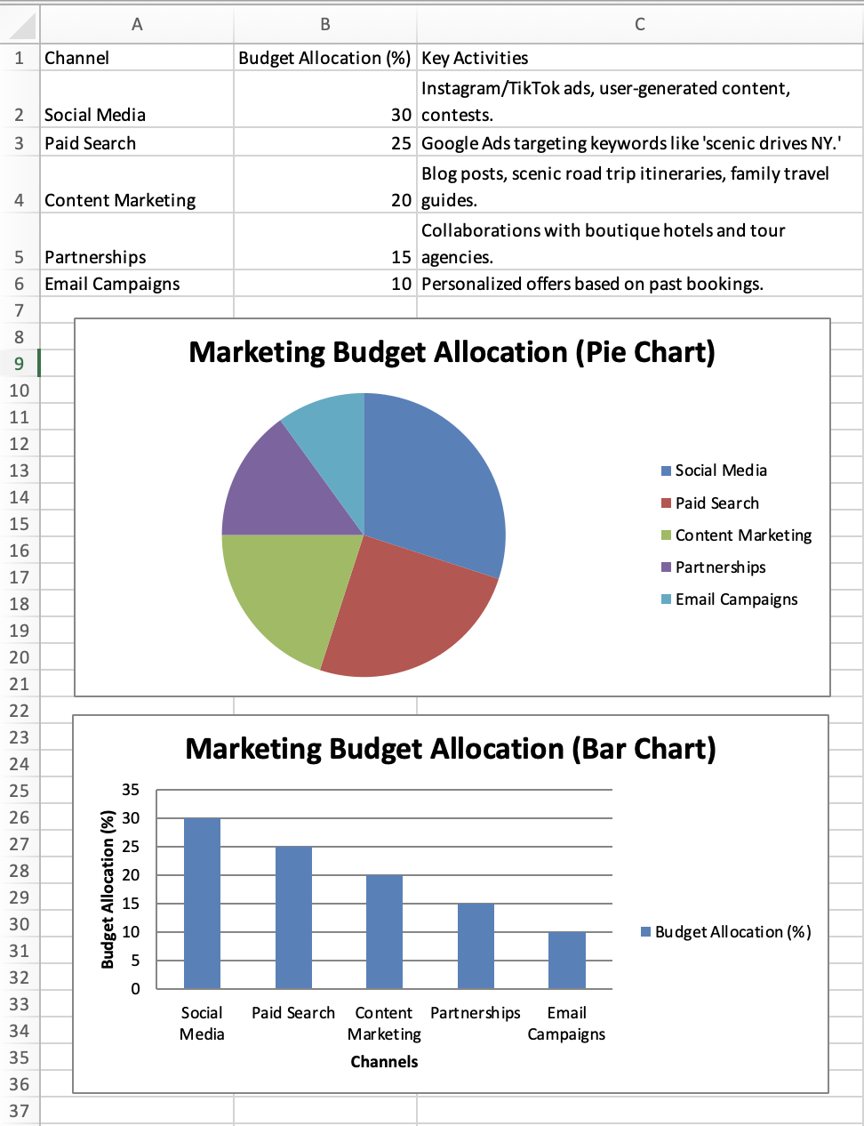
Fig 7: Table for Budget Allocation
Key Insights from Table:
- Social media (30%): The largest portion is used to interact with consumers through TikTok and Instagram advertisements, targeting luxury and adventure travelers.
- Paid Search (25%): Google Ads is used for paid search to guarantee visibility for travel-related queries such as "scenic drives NY."
- Content marketing (20%): Uses family-friendly blogs and adventure-focused guides to gain the confidence of the audience.
- Partnerships (15%): Works with tour operators and boutique hotels to increase awareness and credibility.
- Email campaigns (10%): Retarget current clients with tailored offers to encourage repeat business and loyalty.

5. POSITIONING AND MESSAGING
5.1 Positioning Statement:
“Elevating your New York State journey with luxurious vehicles, curated travel packages, and unforgettable experiences for every type of explorer.”
This claim emphasizes Audi on Demand's dedication to combining high-end automobiles with customized travel options in order to appeal to a wide range of consumers.
5.2 Key Messaging and Ad Campaign Themes:

5.2.1. Adventure Seekers
Theme: "Off the Grid, On the Road"
- Target Audience: Thrill-seekers and explorers aged 20-35 looking to escape urban life and enjoy nature.
- Visuals:
  - Drone shots of Audi SUVs driving through rugged mountain paths and serene lakefronts.
  - Campfires, tents, and scenic stops highlighting flexibility and freedom.
- Tagline:
  - "Where your journey begins and city stress ends."
- Supporting Points:
  - Customizable packages allow explorers to plan offbeat adventures.
  - Rugged and reliable Audi SUVs are perfect for challenging terrains.
  - Scenic routes tailored for a memorable road trip experience.
- Explanation: This campaign theme captures the freedom and excitement adventure seekers crave, positioning Audi as the ultimate partner for their explorations.

5.2.2. Family Tourists
Theme: "Your Family’s Next Great Adventure"
- Target Audience: Families with parents aged 35-50 and children seeking safe and comfortable travel experiences.
- Visuals:
  - Families unpacking picnic baskets at scenic stops.
  - Kids enjoying family-friendly activities at roadside attractions.
  - Smiling parents driving comfortable Audi SUVs or sedans.
- Tagline:
  - "Pack the family. We’ve planned the rest."
- Supporting Points:
  - Kid-safe vehicles designed for family comfort.
  - Pre-planned trips to destinations like the Hudson Valley, Catskills, and Finger Lakes.
  - Family-friendly itineraries with activities suitable for all ages.
- Explanation: This theme emphasizes ease and quality family time, presenting Audi on Demand as a service that ensures safety, comfort, and joy for every member of the family.

5.2.3. Luxury Travelers
Theme: "Refined Roads"
- Target Audience: High-net-worth individuals aged 30-55 who value exclusivity, elegance, and premium experiences.
- Visuals:
  - Audi A8s parked in front of boutique hotels or vineyards.
  - Sunset drives along waterfronts in elegant Audi convertibles.
  - Travelers enjoying champagne at a luxury resort after a scenic drive.
- Tagline:
  - "Drive luxury, discover tranquility."
- Supporting Points:
  - High-end vehicles like the Audi A8 or Q8 cater to sophisticated tastes.
  - Exclusive access to curated tours of vineyards, fine dining, and premium lodging.
  - Chauffeur options for a truly indulgent experience.
- Explanation: This theme aligns with the aspirations of affluent travelers who seek style, comfort, and personalized services, presenting Audi on Demand as their gateway to refined travel.
5.3 Perceptual Map:
Y-Axis: Luxury (Top) ↔ Affordability (Bottom)
X-Axis: Convenience (Right) ↔ Exclusivity (Left)
- Luxury vs. Affordability:
  - Audi on Demand is positioned higher on the luxury scale as it provides access to high-end Audi vehicles, setting it apart from economy car rental services.
  - Traditional rental services like Hertz or Enterprise may lean more toward affordability.
- Convenience vs. Exclusivity:
  - Audi on Demand offers convenience through its digital experience and streamlined booking process, placing it toward the right on the axis.
  - More exclusive, membership-based services (like Porsche Drive or Mercedes-Benz Collection) may prioritize exclusivity over convenience.

Visual Representation (Illustrative Description)
- Top Right (Luxury + Convenience):
  - Audi on Demand: Positioned prominently here, combining premium vehicles with a user-friendly, on-demand platform.
  - Turo (Premium Cars): Comparable in offering luxury options with flexible booking.
- Top Left (Luxury + Exclusivity):
  - Porsche Drive: Focuses on exclusivity and membership.
  - Mercedes-Benz Collection: Targets customers seeking a personalized luxury experience.
- Bottom Right (Affordability + Convenience):
  - Hertz: A conventional car rental service that balances cost with availability.
  - Zipcar: Affordable, with a focus on accessibility and short-term rentals.
- Bottom Left (Affordability + Exclusivity):
  - Budget Rentals (Premium Upgrades): Low-cost rentals with optional luxury upgrades.

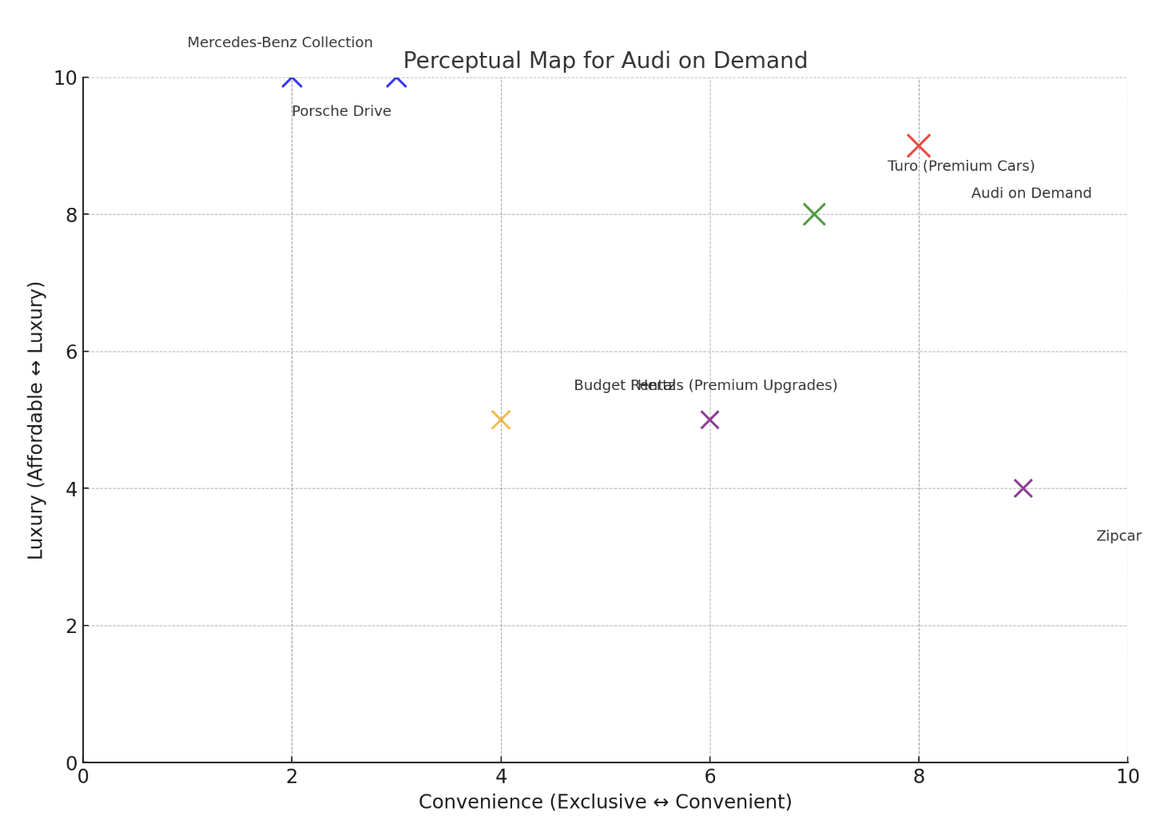

Fig 8: Perceptual Map

6. WEBSITE/APP DESIGN AND CONTENT STRATEGY
6.1 Building User Engagement: The 8 Micro-Yeses Framework for Audi on Demand
The Audi on Demand website aligns with Dr. Flint McGlaughlin’s 8 Micro-Yeses Framework, which emphasizes small commitments that lead to the final conversion. Here’s how the website addresses each micro-yes:

1. Connect
Yes, I will pay attention
- Headline:
"Luxury Meets Convenience: Drive the Audi You Desire On Demand"
  - This clear and bold promise grabs attention by emphasizing both luxury and convenience, aligning with the target audience's expectations.
- Hero Image:
  - A captivating visual of an Audi cruising along a scenic road reinforces the headline and engages visitors visually.
Yes, I will engage deeper
- Subheadline:
"Exclusive Travel and Business Solutions – Experience Premium Travel Today!"
  - This subheadline builds curiosity, enticing users to explore the offerings further.
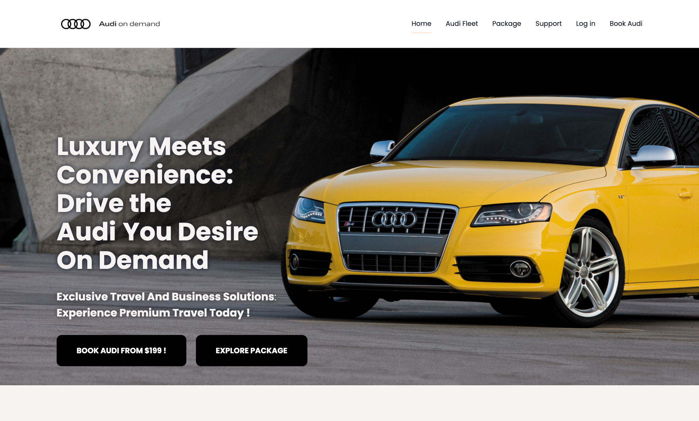

2. Explain
Yes, I understand
- What We Offer Section:
  - Clearly outlines the services provided:
    - Luxury Vehicle Fleets: High-end Audi cars tailored for various needs.
    - Scenic Travel Packages: Tailored trips for Adventure Seekers, Family Tourists, and Luxury Travelers.
    - Corporate and Airport Services: Reliable and premium travel solutions for businesses and individuals.
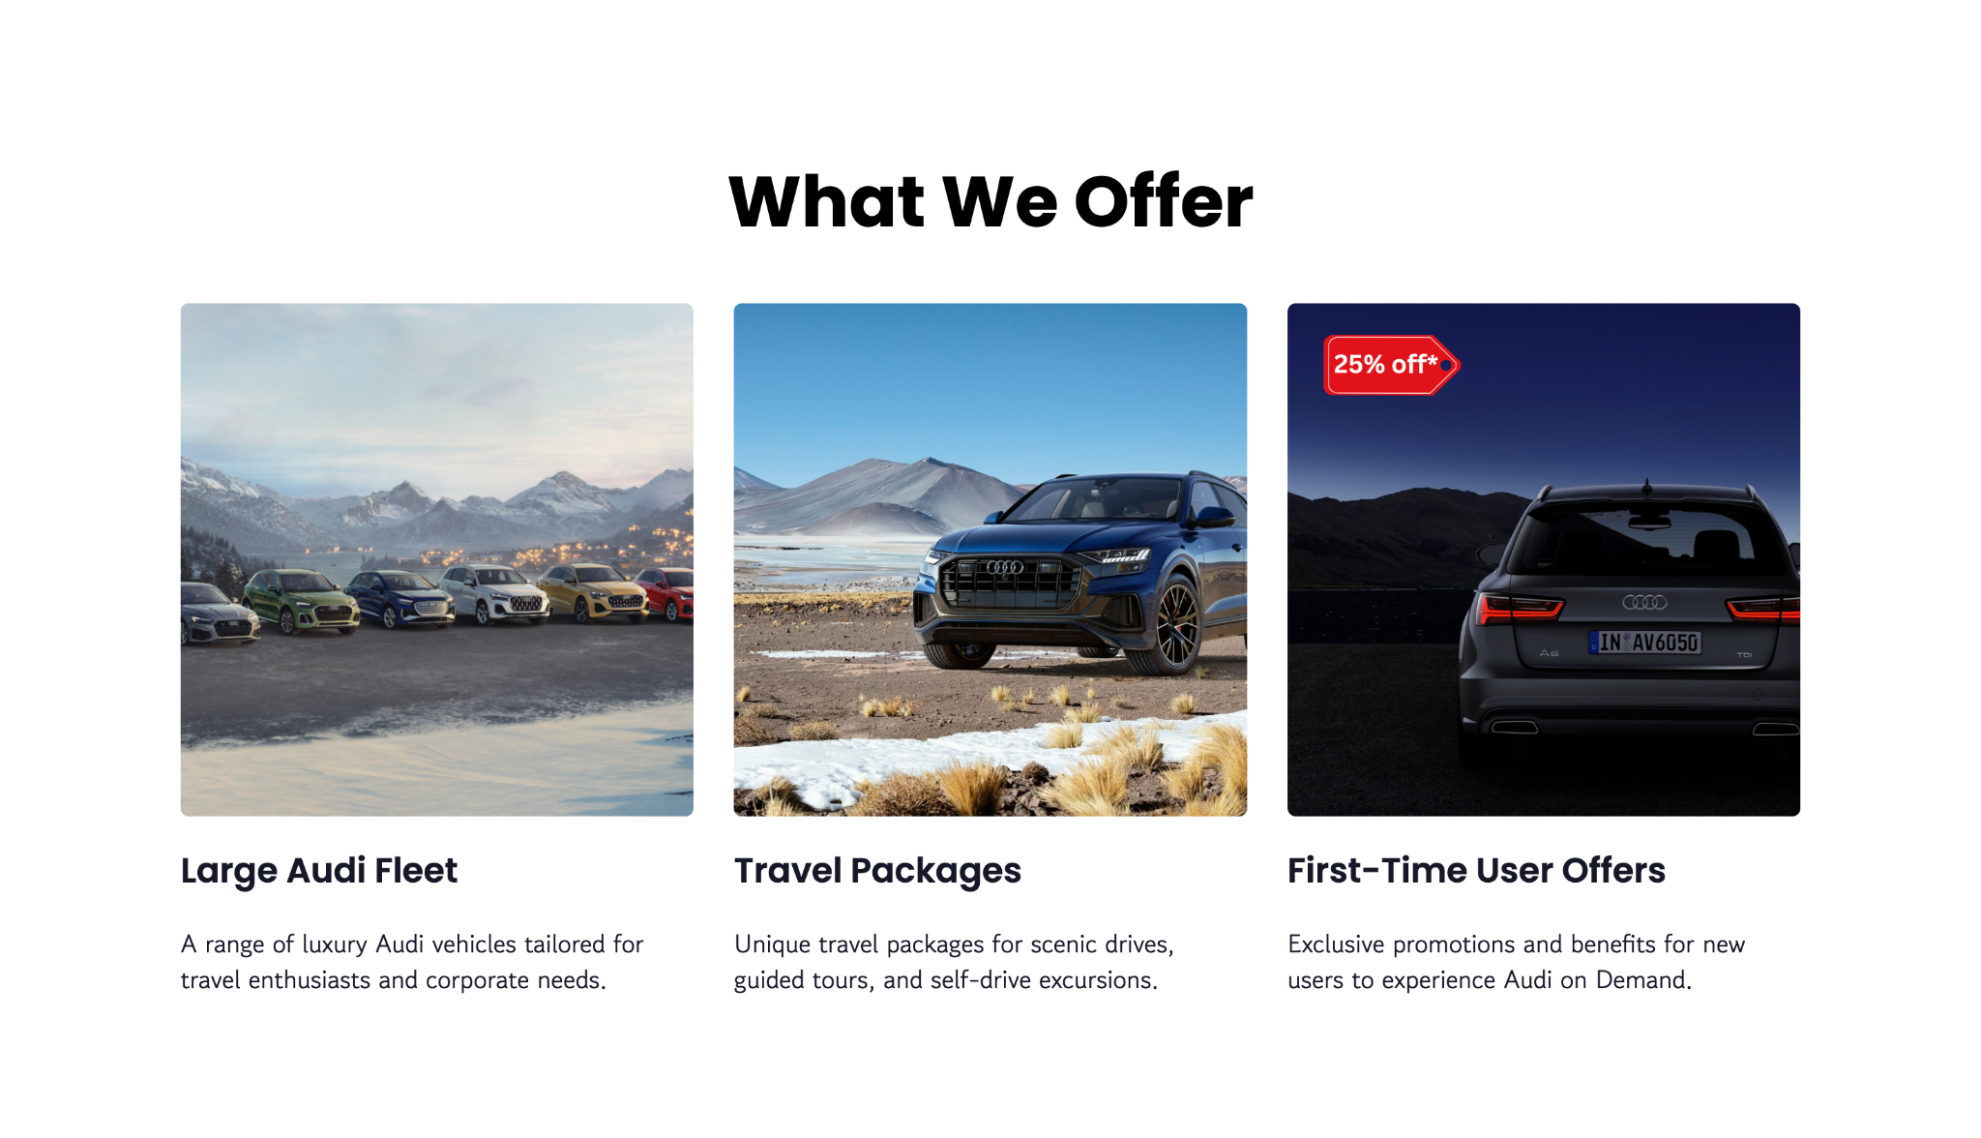
Yes, I believe (you)
- Social Proof:
  - Include testimonials like:
"I booked an Audi on Demand for a weekend trip, and it was the highlight of my journey!"
Sarah Thomas, Customer for 3 years
  - This feedback adds credibility and builds trust by highlighting positive customer experiences.
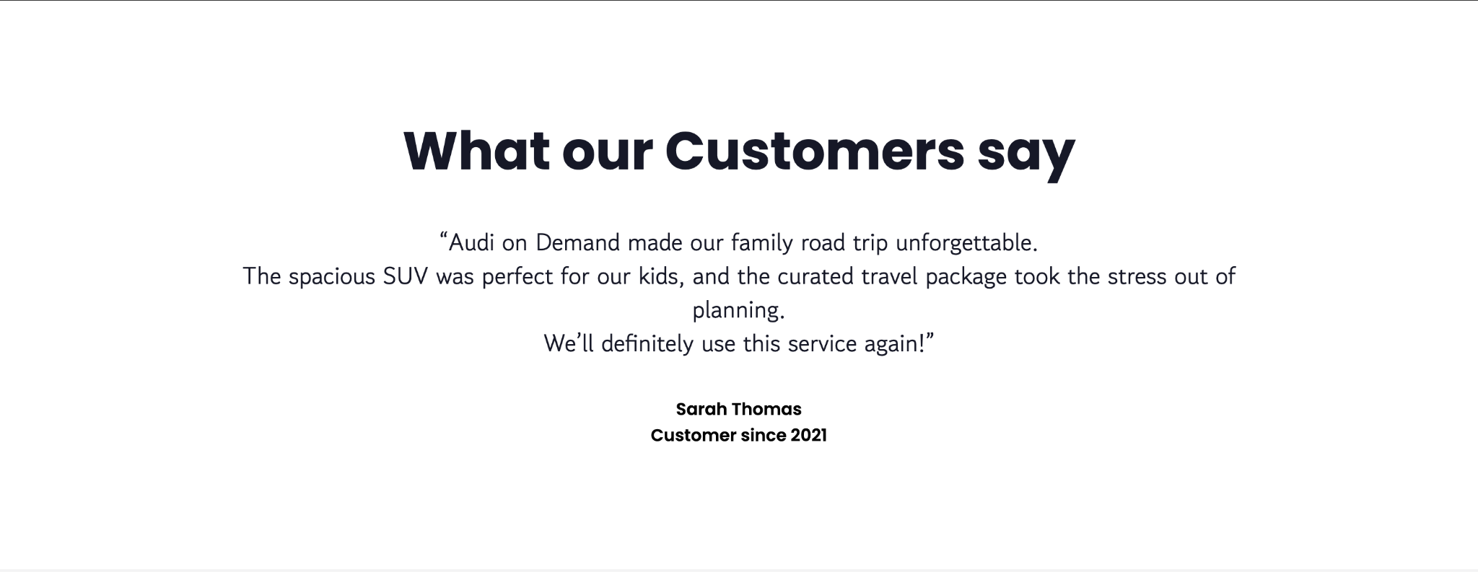

3. Persuade
Yes, I want this now
- Why Act Now Section:
  - Create urgency with limited-time offers:
    - "Enjoy up to 25% off your first booking!"
- These time-sensitive promotions motivate immediate action.
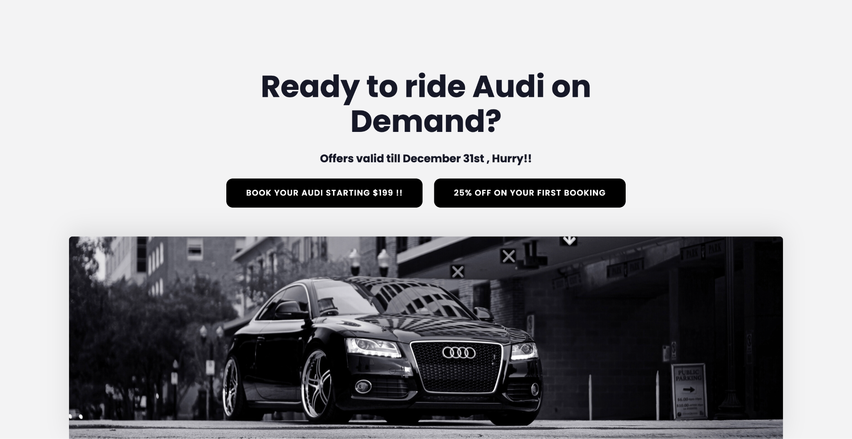
Yes, I want this from you
- Why Choose Audi On Demand Section:
  - Highlight unique benefits:
    - Tailored Experiences: Packages designed for adventure, family trips, and luxury travel.
    - Premium Vehicles: High-end Audi cars equipped with advanced features.
    - Trusted Reputation: Recognized by businesses and travel enthusiasts alike.
    - 24/7 Support: Reliable and responsive customer service.
  - This emphasizes the value Audi on Demand provides without direct comparisons to competitors.
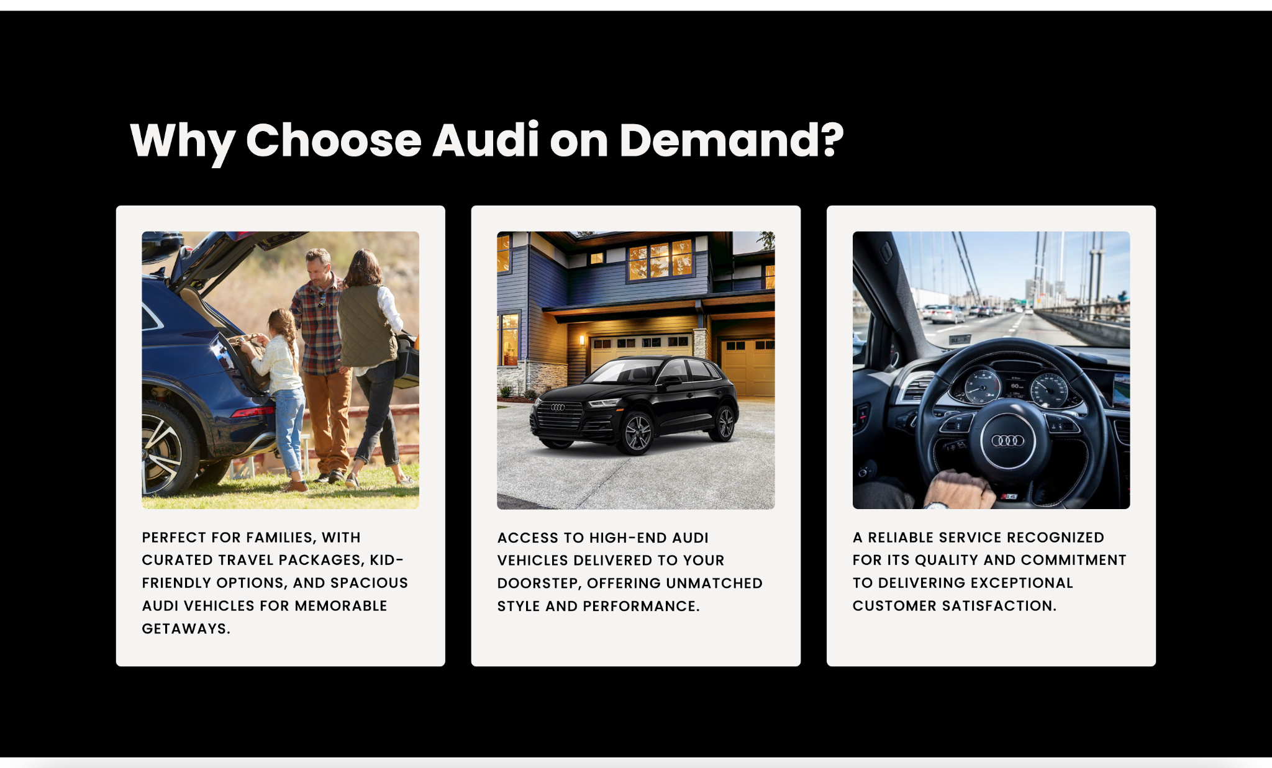

4. Exchange
Yes, I will trade
- Clear Value Proposition:
  - "Book Your Audi Today – Starting at Just $199!"
  - This straightforward statement makes the offer transparent and compelling, showing what customers get for their money.
Yes, I will finish
- Call-to-Action (CTA) Buttons:
  - "Explore Packages" and "Book Your Audi Starting $199!"
  - These CTAs are action-oriented, making it clear and easy for users to proceed with booking or exploring more options.
Reassurance Statement:
- "Hassle-free booking, secure payment options, and 24/7 customer support."
  - This reduces friction by addressing potential concerns, and ensuring users feel confident about completing their booking.

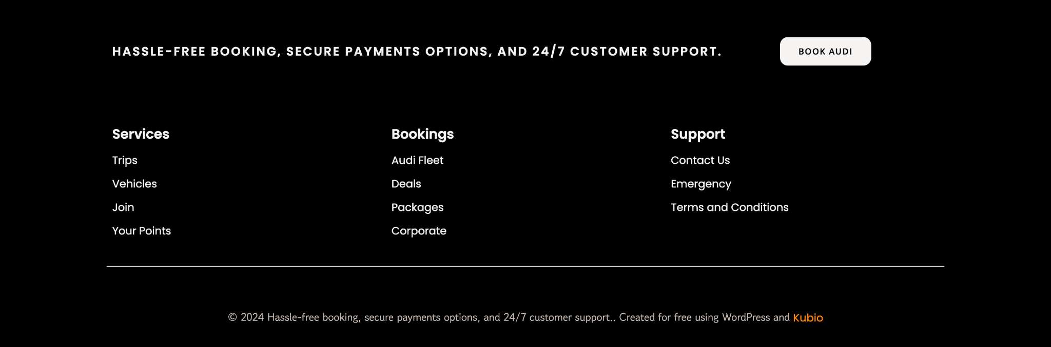

6.2. Driving Inspiration: Blog Topics to Elevate the Audi on Demand Travel Experience
6.2.1 For Adventure Seekers
- "Top 5 Scenic Drives Near NYC for the Adventurer in You"
  - Highlight routes like the Catskills, Adirondacks, and Finger Lakes.
  - Include tips for offbeat stops, hiking trails, and outdoor activities.
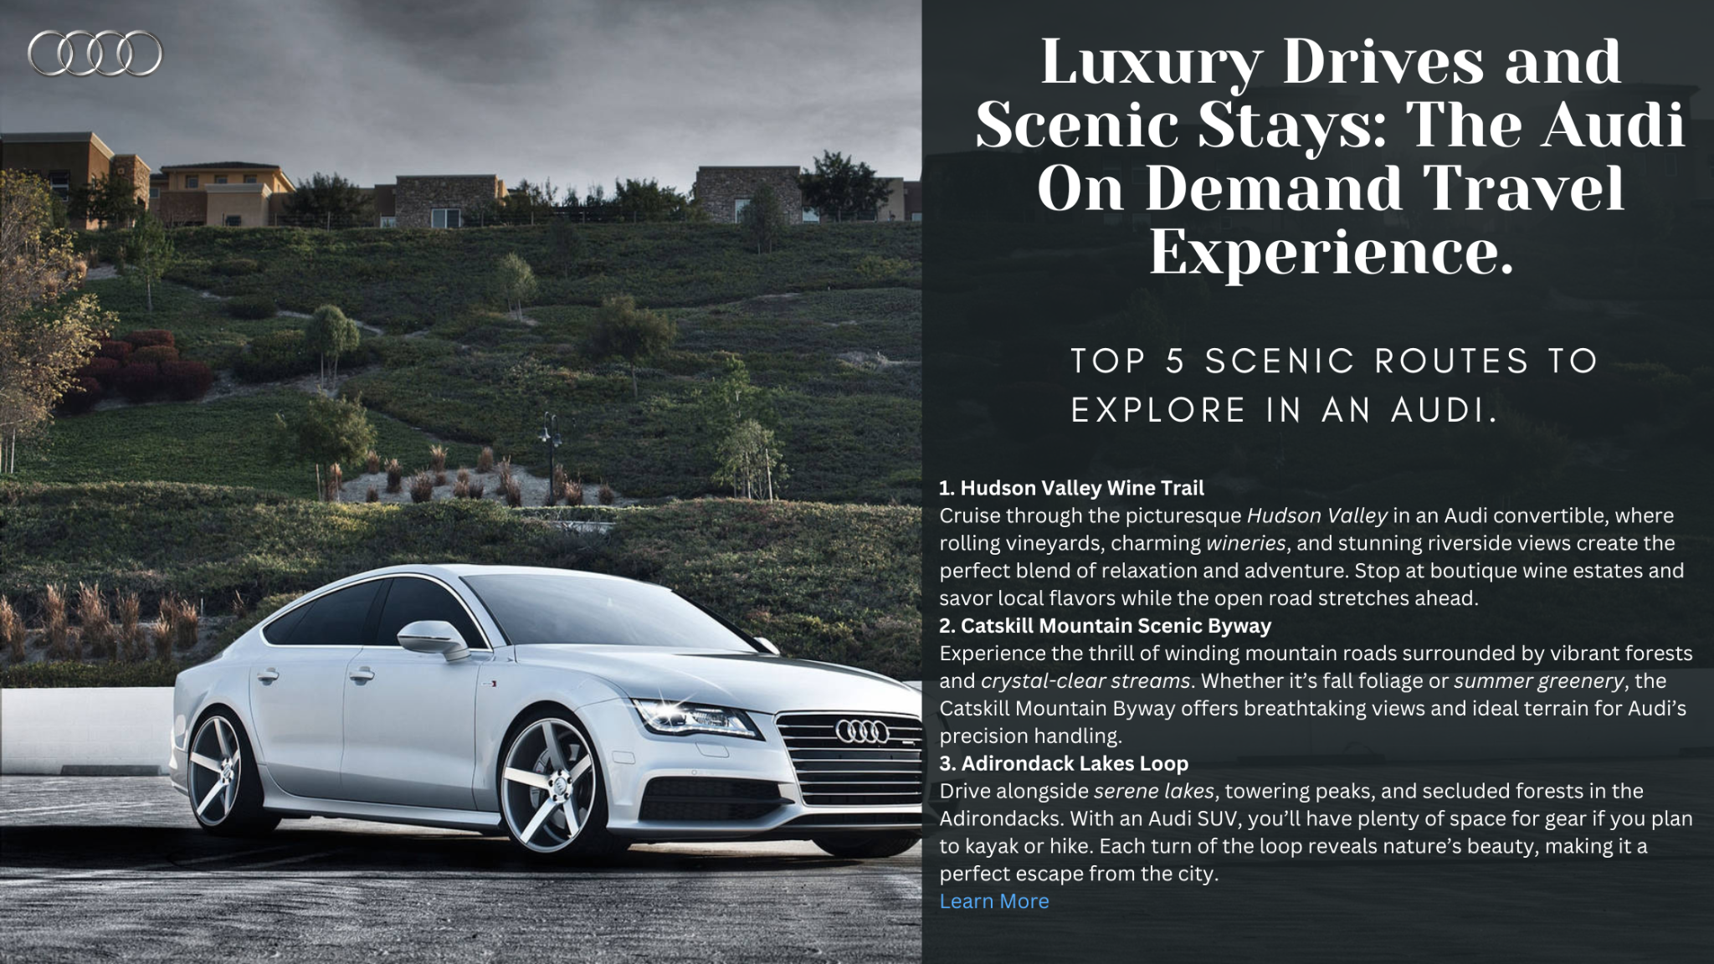
Fig 9: A blog post mockup for the website
- "Why Audi SUVs Are the Perfect Companion for Your Next Road Trip"
  - Focus on the features of Audi’s SUVs, like spacious interiors, advanced navigation, and off-road capabilities.
- "Weekend Escapes: Adventure-Ready Getaways in New York State"
  - Curate travel itineraries featuring rugged destinations paired with Audi vehicles.

6.2.2 For Family Tourists
1. "Family-Friendly Road Trips from NYC: 3-Day Itineraries You’ll Love"
  - Showcase trips to Hudson Valley or Long Island with stops at kid-friendly attractions.
2. "How Audi on Demand Makes Family Travel Safe and Comfortable"
  - Emphasize safety features, spacious interiors, and stress-free booking for families.
3. "The Ultimate Guide to Packing for a Family Road Trip"
  - Practical tips for making the most of a trip with kids, including must-haves for comfort and entertainment.

6.2.3 For Luxury Travelers
- "5 Luxurious Getaways You Can Drive to with Audi on Demand"
  - Highlight boutique hotels, vineyards, and high-end lodges accessible by car.
- "Travel in Style: How Audi Vehicles Redefine Luxury on the Road"
  - Explore the premium features of Audi sedans and convertibles.
- "NYC to the Hamptons: The Perfect Audi Getaway"
  - A premium itinerary for those seeking a high-end coastal retreat.

6.2.4 For All Audiences
- "How to Choose the Perfect Audi Vehicle for Your Next Adventure"
  - A guide to selecting the right car based on trip type (e.g., SUV for families, convertible for couples).
- "What Sets Audi on Demand Apart from Traditional Car Rentals?"
  - A comparison blog highlighting key differentiators like convenience, luxury, and customization.
- "The Environmental Advantage of Audi’s Electric Fleet"
  - Promote Audi’s eco-friendly vehicles for conscious travelers.

7. FINANCIAL PROJECTIONS
This section offers thorough projections of the Audi on Demand Travel Experience's possible earnings, related expenses, and return on investment (ROI). A clear financial future for this endeavor is ensured by the projections, which are grounded in market data and reasonable assumptions.

7.1 Revenue Projections
Objective: Estimate potential earnings based on customer demand and package pricing.
Revenue Streams:
- Travel Package Bookings:
  - Revenue from bookings across the three primary audience segments: Adventure Seekers, Family Tourists, and Luxury Travelers.
- Add-On Services:
  - Options such as chauffeur services, upgraded accommodations, guided tours, and dining experiences.
- First-Time User Offers:
  - Attracting new customers with a promotional discount to build long-term loyalty.
Assumptions:
- Customer Base:
  - Luxury Travelers: 2,000 bookings annually.
  - Adventure/Family Travelers: 3,000 bookings annually.
- Average Booking Price:
  - Luxury Packages: $5,000.
  - Adventure/Family Packages: $2,000.
- Add-On Revenue: 20% of bookings purchase add-ons, with an average add-on value of $500.

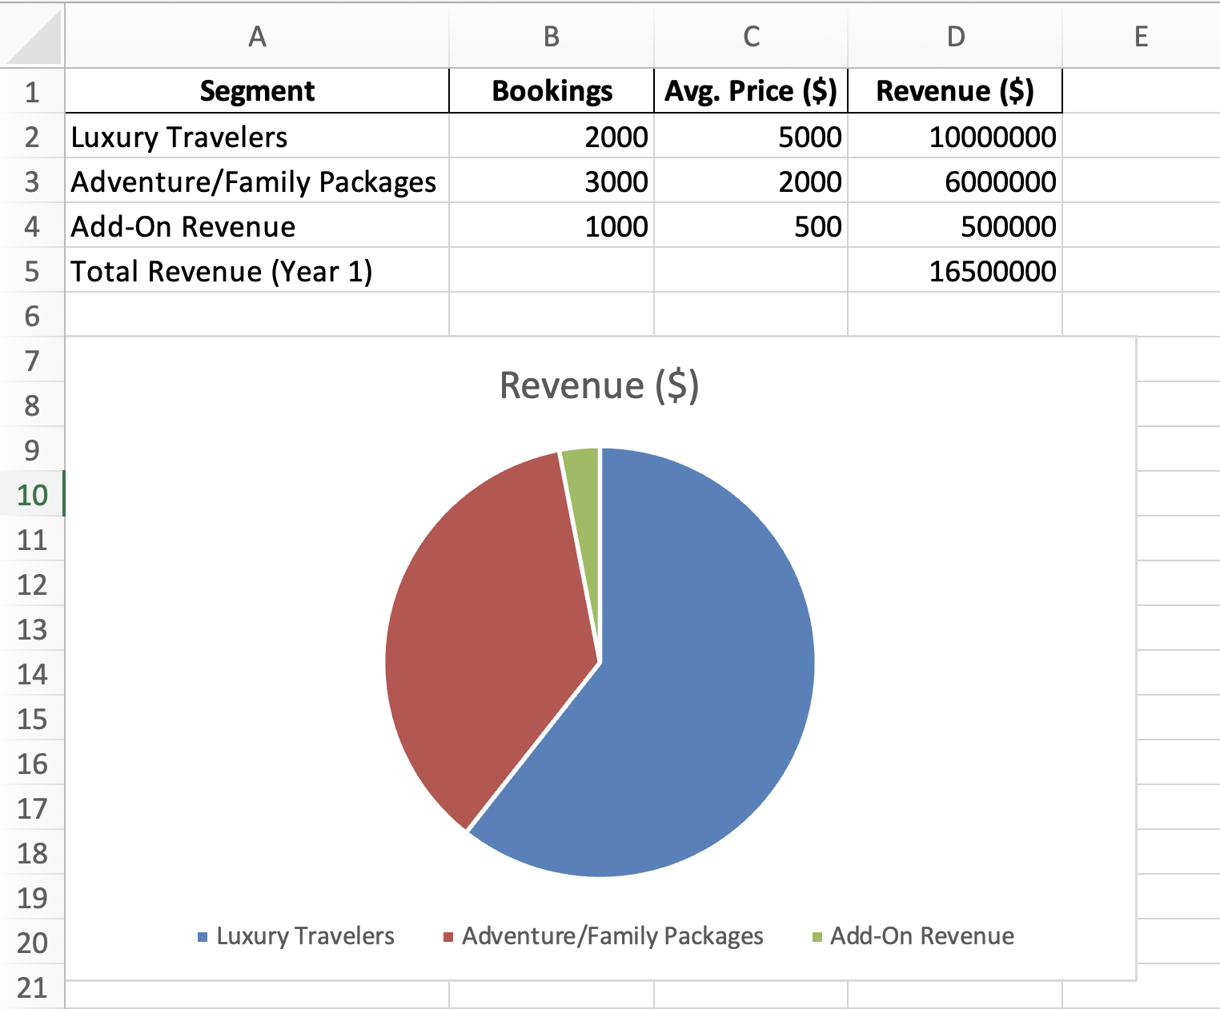
Fig 10: Revenue Projection table

7.2 Cost Projections
Objective: Provide a detailed breakdown of expenses required to operate and scale the initiative.
Categories:
- Marketing Costs:
  - Digital advertising (SEM, social media, influencer campaigns).
  - Content creation (videos, blogs, and visuals).
- Technology Costs:
  - Development of the website and app, including booking and customization features.
  - Maintenance, updates, and UX/UI testing.
- Partnership Costs:
  - Collaborations with premium lodging, restaurants, and tourism boards.
- Operational Costs:
  - Customer service teams, vehicle maintenance, and logistics for seamless execution.
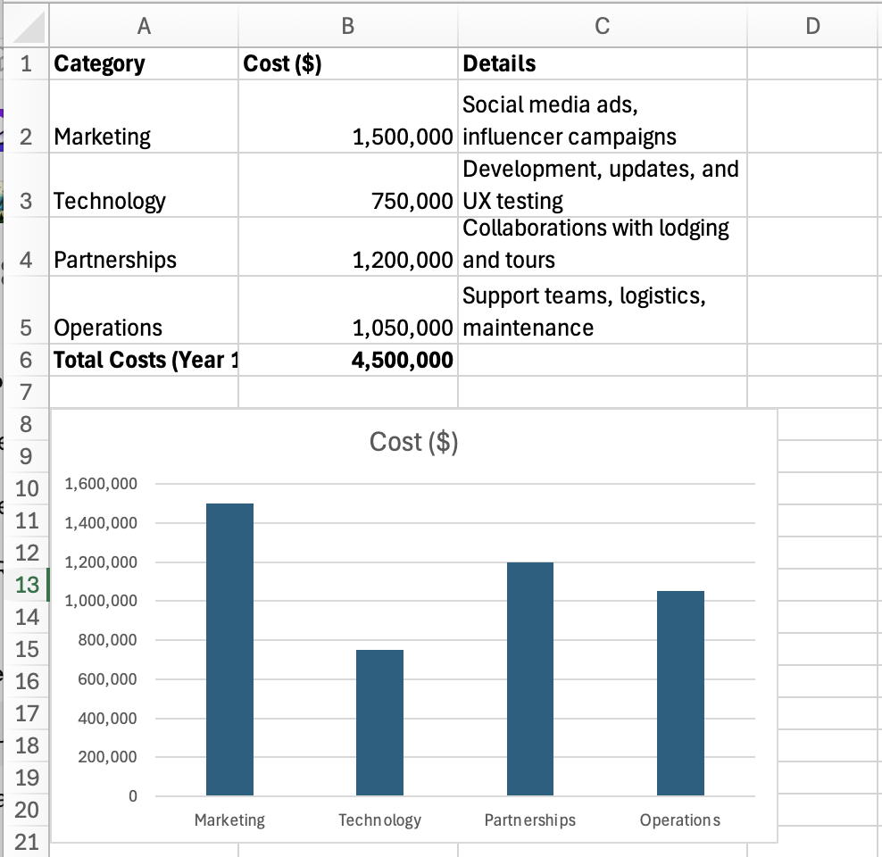
Fig 11: Year 1 Cost Allocation by Category

7.3 ROI Estimates
Objective: Evaluate profitability by comparing revenue to costs.
Formula:
ROI = (Total Revenue - Total Costs) ÷ Total Costs × 100%
Year 1 ROI Calculation:
- Total Revenue: $16,500,000
- Total Costs: $4,500,000
- ROI:
((16,500,000 - 4,500,000) ÷ 4,500,000) × 100% = 266%

7.4 Year-by-Year Growth Projections
We assume a 20% increase in bookings annually due to enhanced marketing efforts and expanding partnerships. Costs are expected to rise by 10% annually due to scaling.
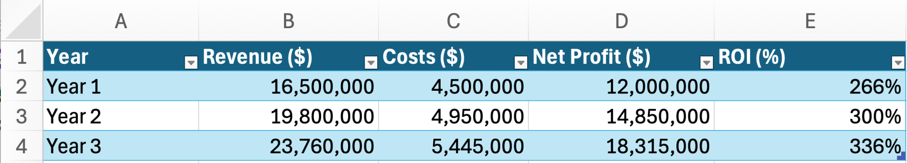
Fig 12: Year-by-Year Growth Projections
7.5 Sensitivity Analysis
Objective: Evaluate the financial impact of varying key factors.
- Impact of Customer Growth:
  - If bookings grow by 25% annually instead of 20%, revenue in Year 3 increases to $25,740,000.
  - If growth drops to 15% annually, revenue in Year 3 reduces to $22,190,000.
- Impact of Add-Ons:
  - If add-on purchases increase to 30% of bookings, additional Year 1 revenue grows to $750,000.
  - A drop to 10% reduces add-on revenue to $250,000.

7.6 Financial Risks
Objective: Identify potential challenges and mitigation strategies.
- Lower-than-Expected Demand:
  - Risk: Fewer bookings than projected.
  - Mitigation: Intensify marketing efforts and introduce discounts to attract customers.
- Rising Costs:
  - Risk: Increased operational and partnership costs.
  - Mitigation: Optimize processes and negotiate better rates with partners.
- Economic Downturn:
  - Risk: Reduced luxury spending by customers.
  - Mitigation: Promote flexible, affordable travel options for cost-conscious travelers.

8. IMPLEMENTATION PLAN
Implementation Plan: Planning, Launch, and Optimization Phases

8.1. Planning Phase (Months 1–3)

Market Research and Analysis:

To determine travel preferences and pain issues, conduct focus groups and surveys with NYC residents.

To identify gaps and possibilities, examine the tactics used by rivals in the luxury travel and vehicle rental industries.

Use data analytics to research New York travel patterns and consumer behavior.

Develop Offerings and Partnerships:

Complete customized travel packages for three important market segments: luxury travelers, family vacationers, and adventure seekers.

To generate special offers and increase package value, collaborate with upscale local hotels, fine eating establishments, and tourist destinations.

To increase reach, discuss co-branded marketing opportunities with partners.

Website and App Preparation:

Complete the essential elements, such as an integrated route planner, easy booking options, and trip personalization choices.

Give top priority to a user-centric, mobile-first design to guarantee seamless navigation and an excellent user experience.

To get rid of issues and guarantee platform dependability at launch, do a lot of testing.

Ad Campaign Development:

Design compelling content for social media, paid ads, and email campaigns tailored to target audiences.

Develop professional visuals and videos for each campaign theme:

Adventure Seekers: Scenic routes, rugged Audi SUVs.

Family Tourists: Safe, comfortable drives with family-friendly stops.

Luxury Travelers: Elegant drives, premium accommodations, and exclusivity.

Plan influencer partnerships to amplify campaign visibility.

Budget Allocation:

Distribute funds strategically:

Marketing: Social media ads, Google Ads, influencer partnerships.

Partnerships: Exclusive deals with hotels, restaurants, and tourist attractions.

Technology: Finalizing and optimizing the website and app.

8.2. Launch Phase (Months 4–6)

Soft Launch:

Introduce travel packages to a select group of pilot users for testing and gathering actionable feedback.

Use early customer feedback to fine-tune offerings, address issues, and improve the user experience.

Gather testimonials, photos, and videos from pilot users for authentic promotional content.

Marketing Rollout:

Launch digital campaigns across Instagram, TikTok, and Google Ads, targeting segments with personalized messaging.

Deploy email marketing campaigns offering introductory discounts and first-time user incentives.

Collaborate with NYC-based influencers and bloggers to create organic buzz around the launch.

Public Launch Event:

Host an exclusive launch event in NYC showcasing Audi vehicles, interactive travel kiosks, and special on-the-spot booking offers.

Invite media, influencers, and potential customers to experience the brand firsthand.

Livestream the event across platforms for broader online engagement and visibility.

Monitor Performance:

Track KPIs such as:

Website traffic.

App downloads.

Conversion rates (from visits to bookings).

Use real-time data to adjust campaigns and address any initial roadblocks.

8.3. Optimization Phase (Months 7–12)

Analyze Data:

Use tools like Google Analytics to evaluate customer behaviors, high-performing packages, and regional trends.

Assess marketing metrics such as cost per click (CPC), click-through rates (CTR), and return on investment (ROI).

Iterate Offerings:

Enhance travel packages based on customer feedback, including adding new destinations and activities.

Adjust package pricing to align with seasonal demand (e.g., higher pricing for peak seasons).

Enhance Marketing Strategies:

Refine audience targeting by focusing on high-performing demographics.

Shift marketing budgets to prioritize the most effective channels (e.g., TikTok over Instagram if engagement is higher).

Develop seasonal campaigns (e.g., “Fall Foliage Scenic Drives” or “Summer Coastal Adventures”).

Introduce Loyalty Program:

Launch a rewards program for repeat customers:

Offer points are redeemable for discounts, free upgrades, or exclusive deals.

Highlight the benefits of loyalty through targeted marketing campaigns.

Continuous Improvement:

Regularly update the website and app with:

Enhanced user interfaces and new features (e.g., AI-based route recommendations).

Fresh blog content to drive SEO and user engagement.

Introduce limited-time offers or holiday-themed packages to maintain interest and bookings.

9. SUPPORTING WORK: SCREENSHOTS, MOCKUPS, AND AD CAMPAIGNS

9.1 Spreadsheets
9.1.1. Budget Allocation Spreadsheet
- Purpose: Tracks expenditures to ensure resources are efficiently allocated and spending remains within the marketing and operational budget.
- Details:
  - Categories: Marketing, partnerships, and operational costs.
  - Subcategories:
    - Marketing: Media buys, influencer collaborations, ad creative development.
    - Partnerships: Lodging collaborations, tourism board agreements, and exclusive deals with restaurants.
    - Technology: Website and app development, UX enhancements, and maintenance.
9.1.2. Campaign Performance Tracker
- Purpose: Evaluates the effectiveness of marketing campaigns by tracking key performance indicators (KPIs).
- Details:
  - Metrics include:
    - Impressions: Number of times the ad was shown.
    - Clicks: Total number of users interacting with the ad.
    - Conversions: Bookings completed as a result of the campaign.
    - ROI: Revenue generated compared to campaign expenditure.
9.1.3. Customer Journey Mapping
- Purpose: Tracks the user journey from first interaction to post-travel feedback, ensuring seamless customer experience.
- Details:
  - Touchpoints: Ad interaction → Landing page visit → Package selection → Booking confirmation → Post-travel survey.

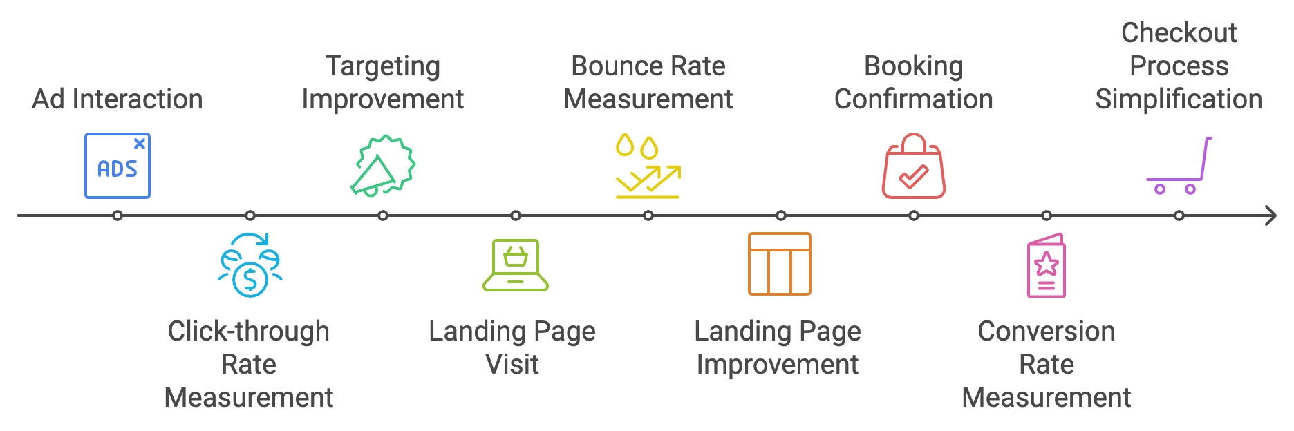
Fig 13: Audi On Demand Advertising and Conversion Process

9.2 Mockups
9.2.1. Website/App Mockups
- Homepage highlighting three primary customer segments.
- Booking page with filters for destination, vehicle type, and trip duration.
- Route planner showcasing recommended itineraries and partner deals.
9.3 Ad Campaigns
A well-structured ad campaign ensures that Audi on Demand Travel Experience effectively appeals to its updated audience segments while showcasing its unique value propositions. Below is the refined plan for targeting three key segments: Travel Package Customers, Luxury Travelers, and First-Time Users.
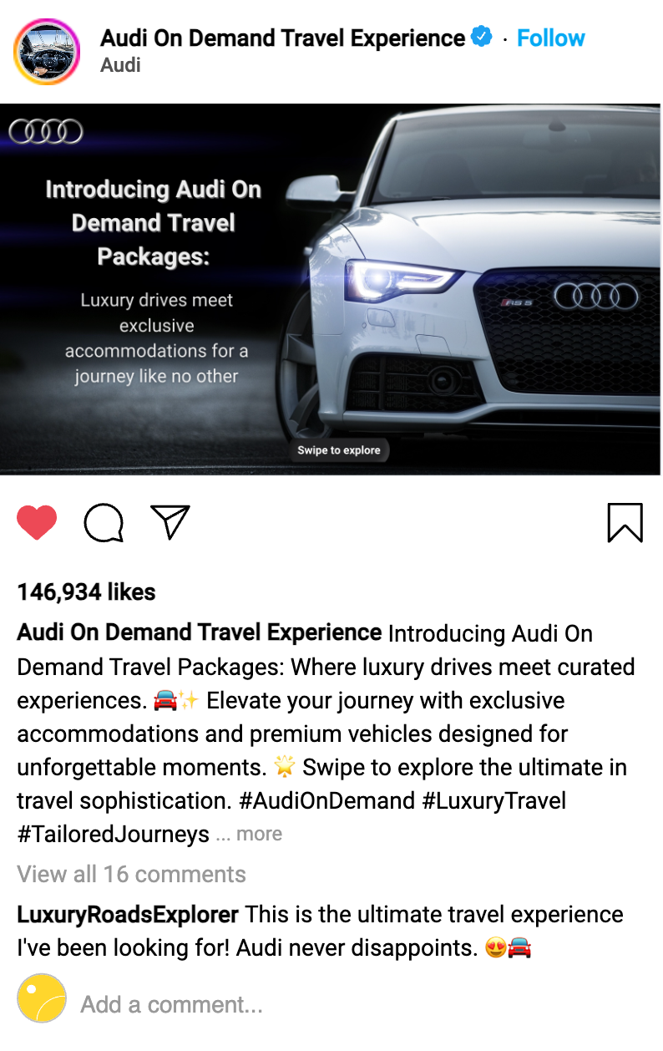
Fig 14: Instagram Post Mockup
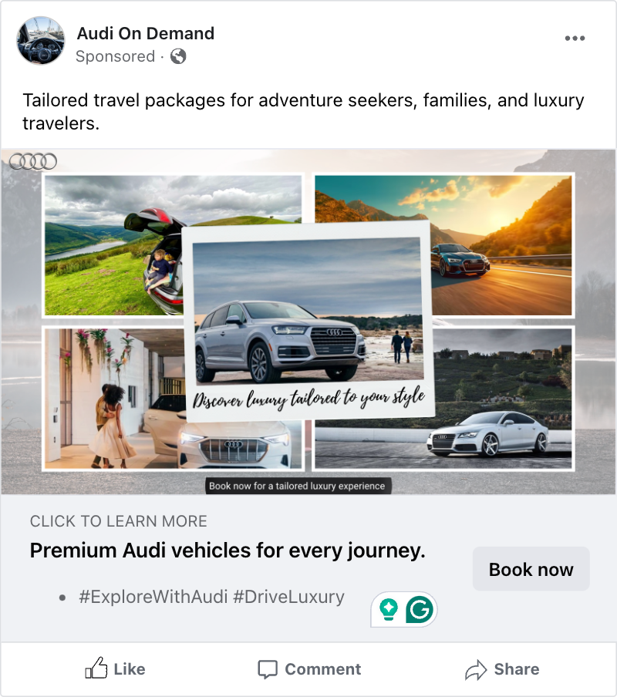
Fig 15: Facebook Mockup Ad.
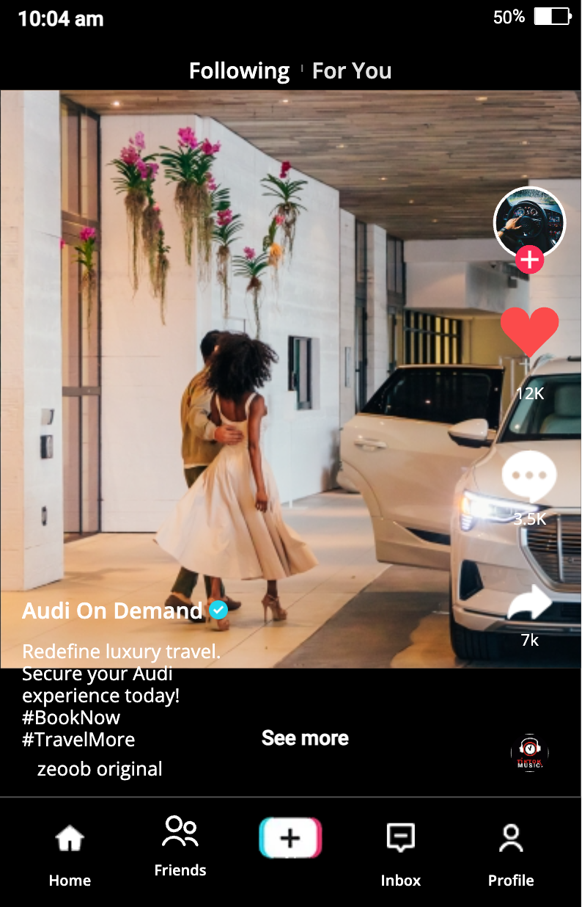
Fig 16: Ad mockup for TikTok

9.3.1. Travel Package Customers
- Platform: Instagram, Google Ads, and YouTube
  - Why These Platforms: Travel package customers are likely to search for vacation options, luxury trips, and unique experiences. Visual platforms like Instagram and YouTube highlight the curated travel experience, while Google Ads target users actively searching for travel packages.
- Content:
  - Video Ads: Showcase curated travel itineraries, such as:
    - A scenic coastal drive in an Audi convertible with stops at boutique hotels.
    - A self-drive mountain adventure in the Adirondacks with Audi SUVs.
  - Dynamic Search Ads: Target keywords like “Luxury travel packages near me” or “Scenic road trip itineraries.”
  - Story Ads: Use Instagram Stories to feature “day in the life” videos of an Audi travel experience, ending with a CTA to book packages.
- CTA:
  - "Explore Exclusive Travel Packages with Audi Today!"
  - Encourages users to browse available packages and plan their next trip.
- Example Campaign Theme:
  - "Curated Drives, Unforgettable Journeys"

9.3.2. Luxury Travelers
- Platform: Instagram, LinkedIn, and YouTube
  - Why These Platforms: Luxury travelers value exclusivity and elegance, which align with the professional and aspirational content found on LinkedIn, as well as the visual storytelling capabilities of Instagram and YouTube.
- Content:
  - High-Quality Visuals:
    - Showcase Audi sedans and SUVs in luxury settings like vineyards, 5-star resorts, and waterfront destinations.
  - Influencer Partnerships: Collaborate with high-profile travel and lifestyle influencers to promote luxury packages and vehicles.
  - Lifestyle Video Ads:
    - Highlight premium features like a chauffeur-driven Audi or bespoke travel itineraries.
- CTA:
  - "Refine Your Journey with Audi’s Exclusive Travel Packages."
  - Encourages bookings with a focus on elegance and sophistication.
- Example Campaign Theme:
  - "Refined Roads, Tailored Luxury"

9.3.3. First-Time Users
- Platform: TikTok, Instagram, and Facebook
  - Why These Platforms: First-time users are more likely to respond to engaging and interactive content, as well as discounts and promotions shared on popular social platforms.
- Content:
  - Promotional Videos:
    - Highlight limited-time offers like “25% off your first booking.”
    - Include testimonials from first-time users about their seamless and enjoyable experience.
  - Interactive Ads:
    - TikTok challenges or Instagram polls asking users about their dream road trip destination.
  - Carousel Ads:
    - Feature entry-level packages with affordable luxury options to entice new customers.
- CTA:
  - "Experience Audi Luxury Today—Enjoy 25% Off Your First Booking!"
  - Motivates immediate action by emphasizing the benefit of being a new customer.
- Example Campaign Theme:
  - "Your First Step into Luxury"

9.4. Screenshots of Pages Created and Plugins Installed
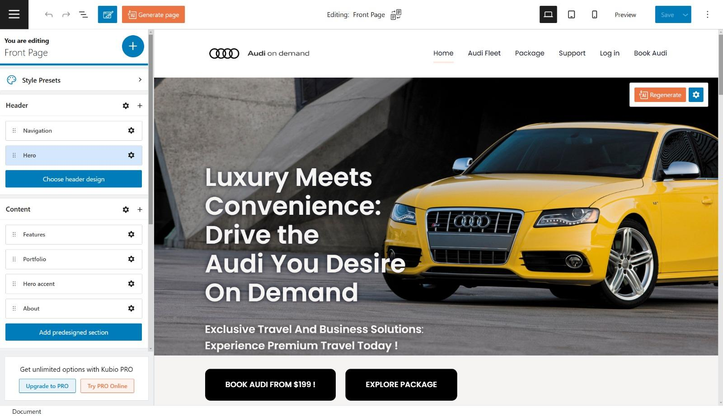
Home Page with Kubio editor
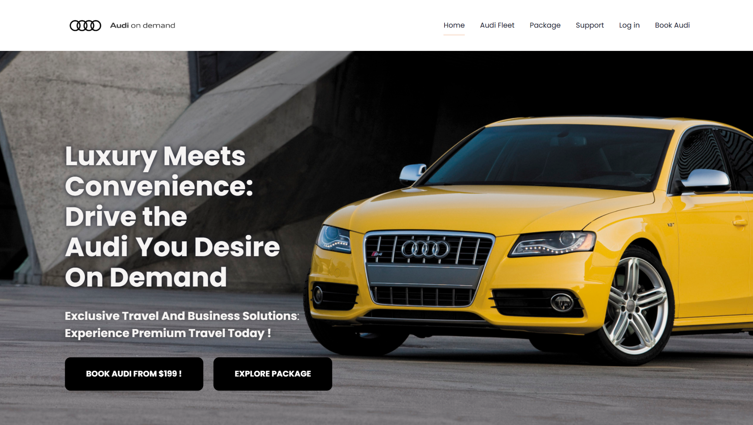
Home Page After editing
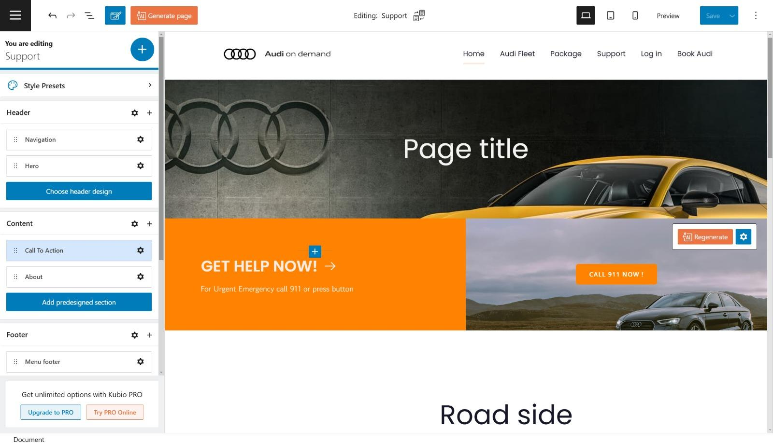
Support page with Kubio editor
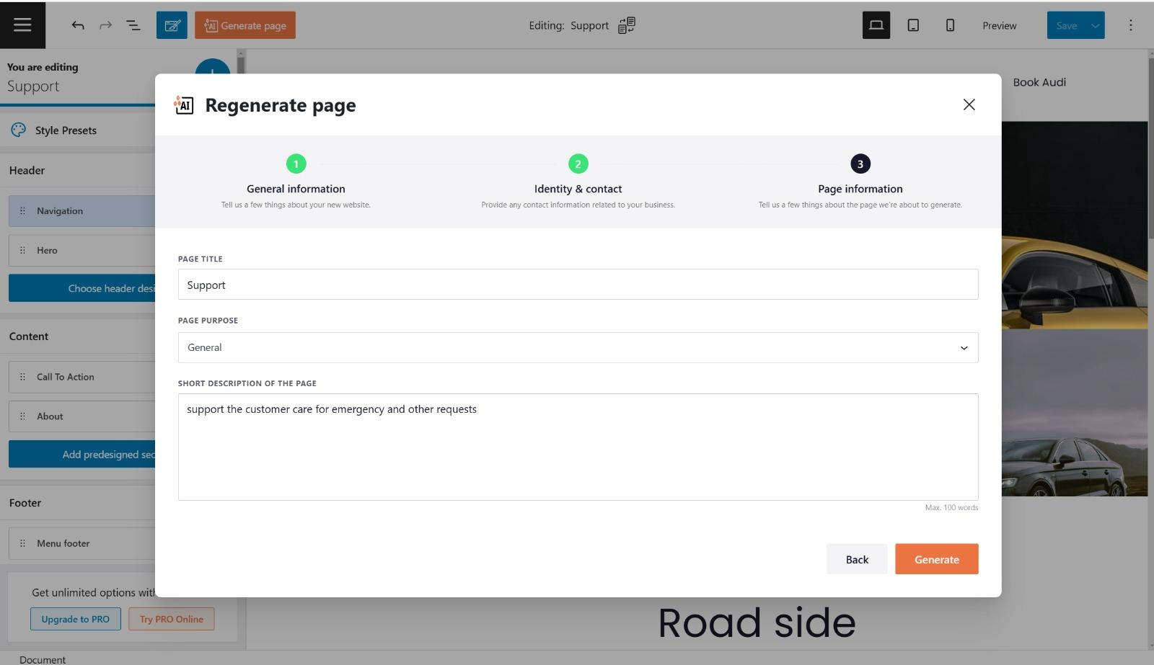
Adding sections to Support page with Kubio editor AI regenerate feature

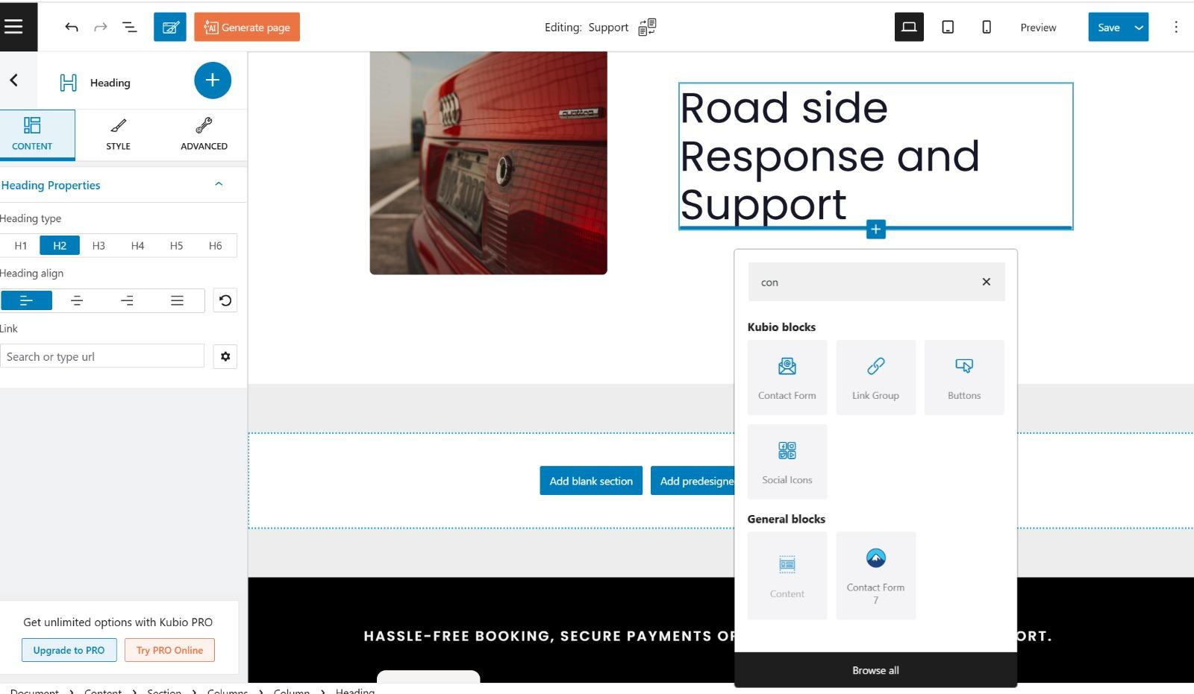
Adding form section to Support page which uses Contact form plugin

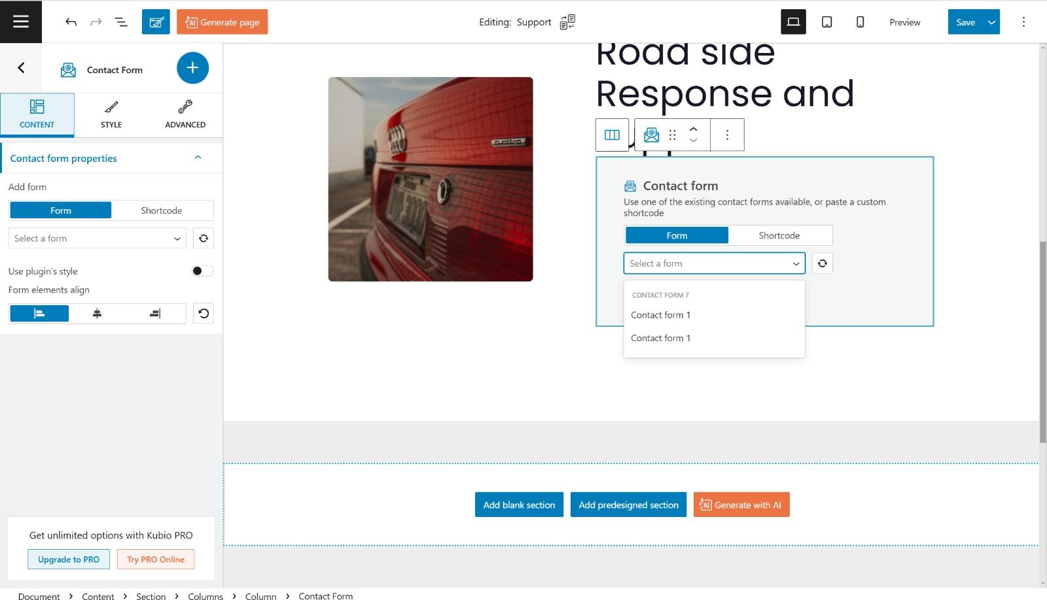
Selecting the designed form to add in Support page
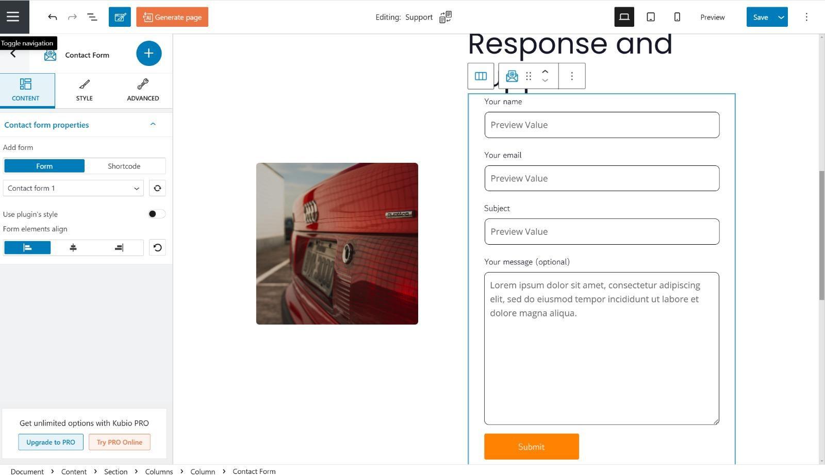
Form section added to Support page which uses Contact form plugin
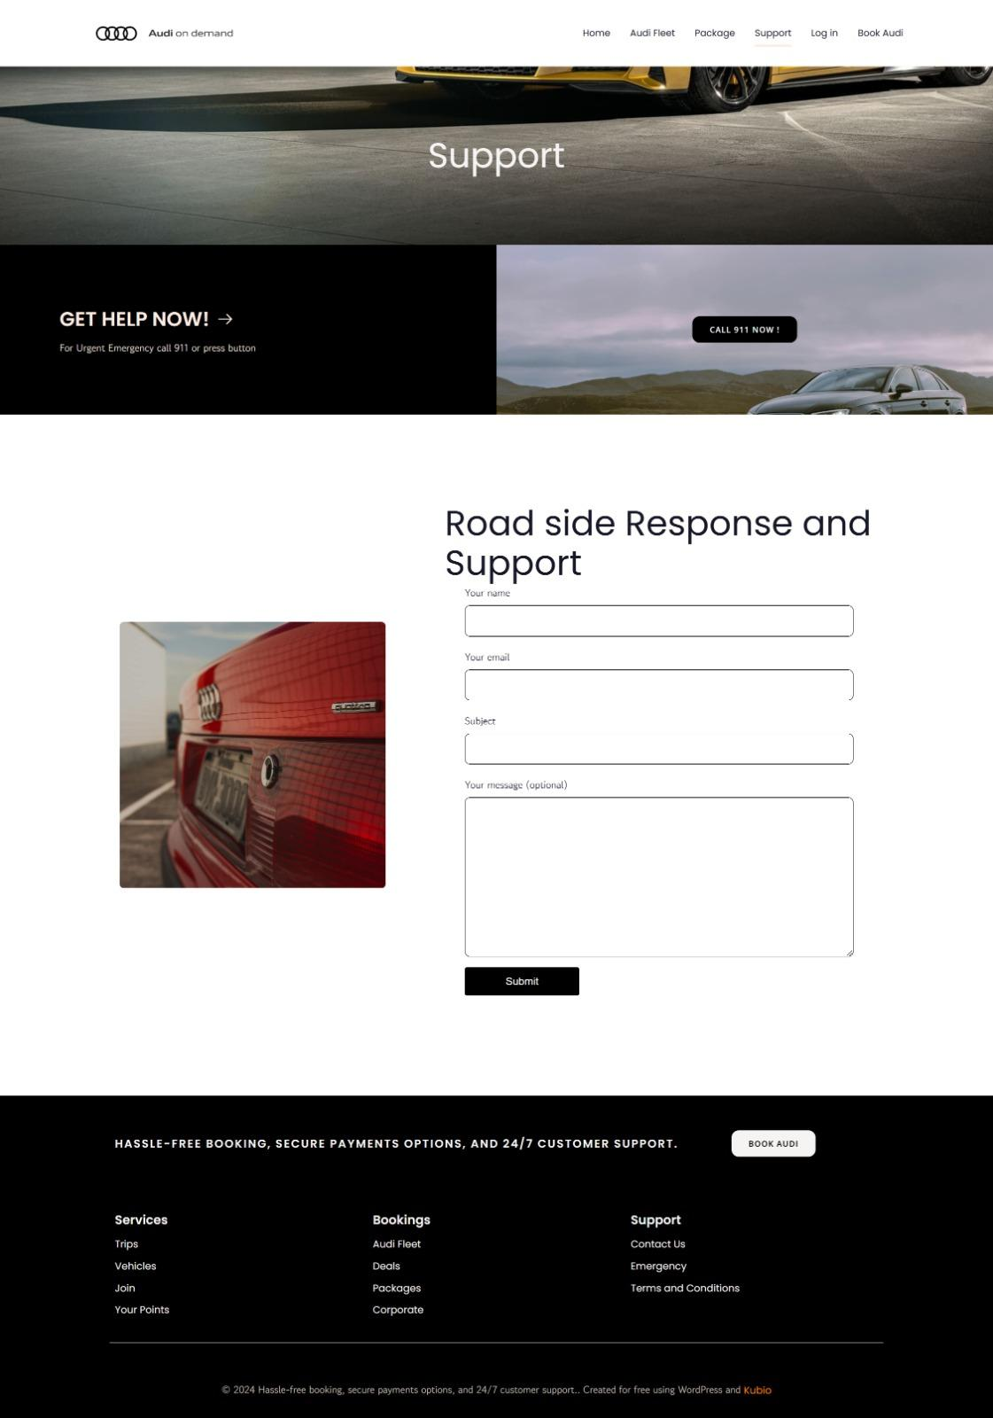
Support page complete view

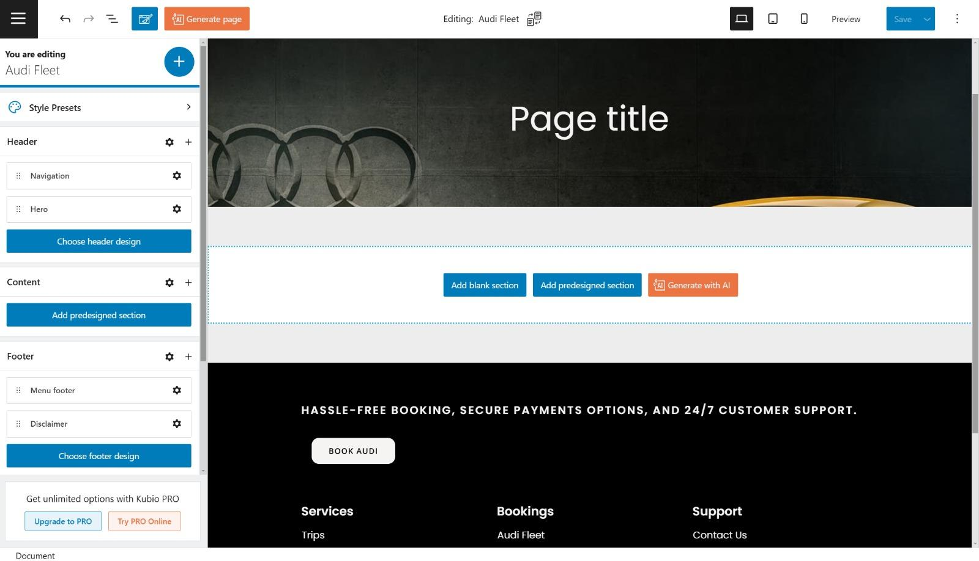
Audi fleet page with Kubio editor
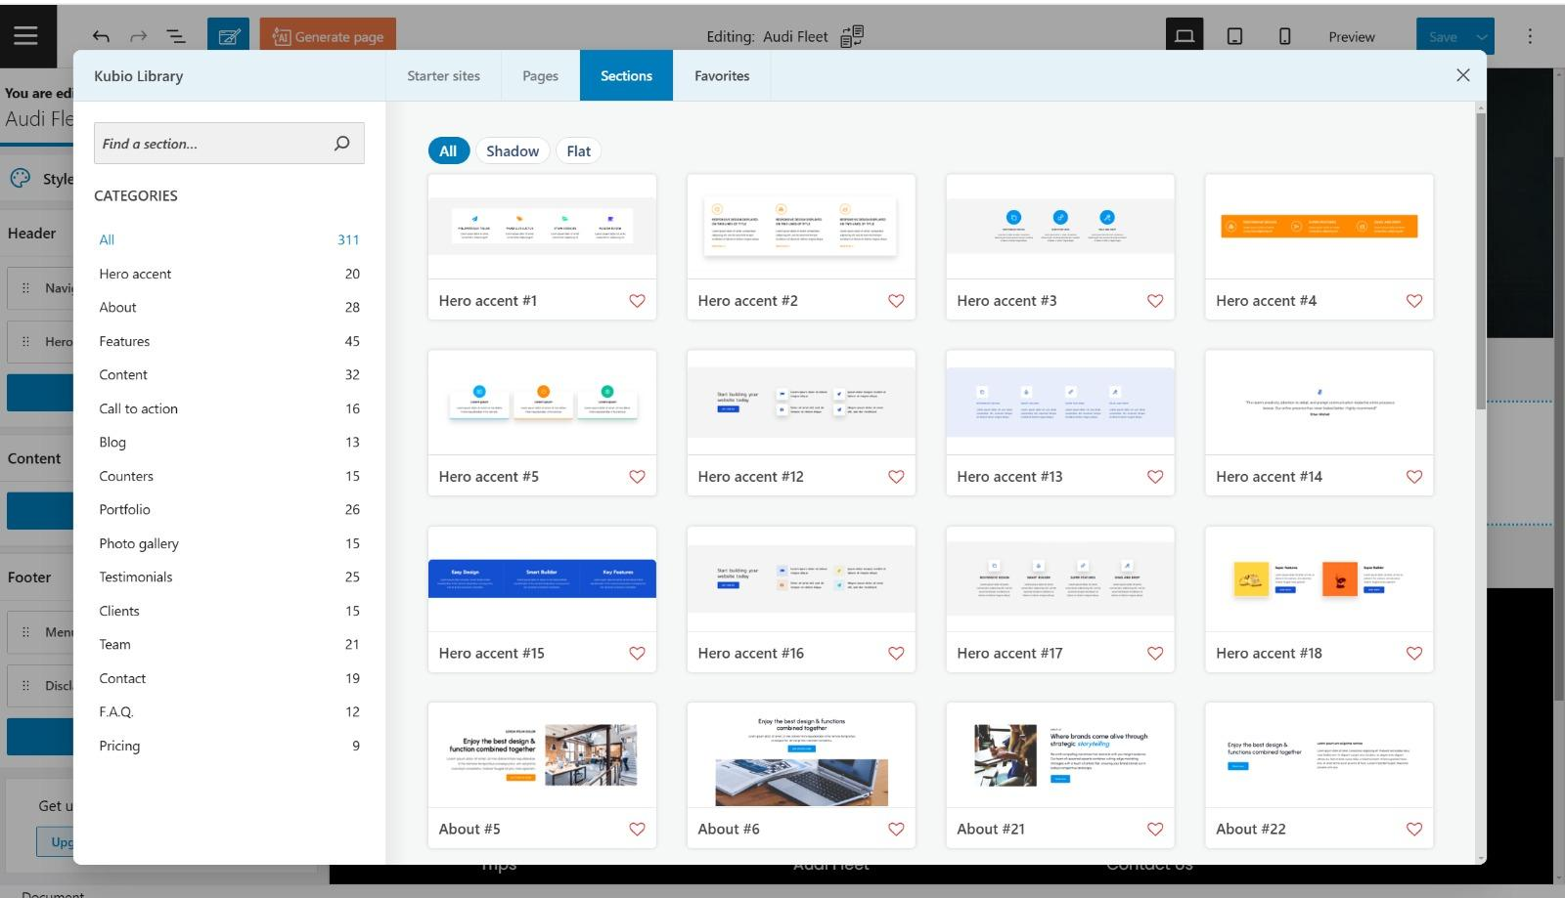
Adding sections to Audi fleet page
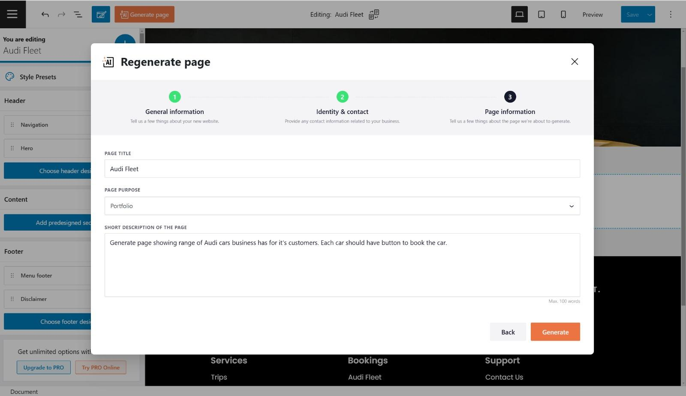
Adding sections to Audi fleet page with Kubio editor AI regenerate feature
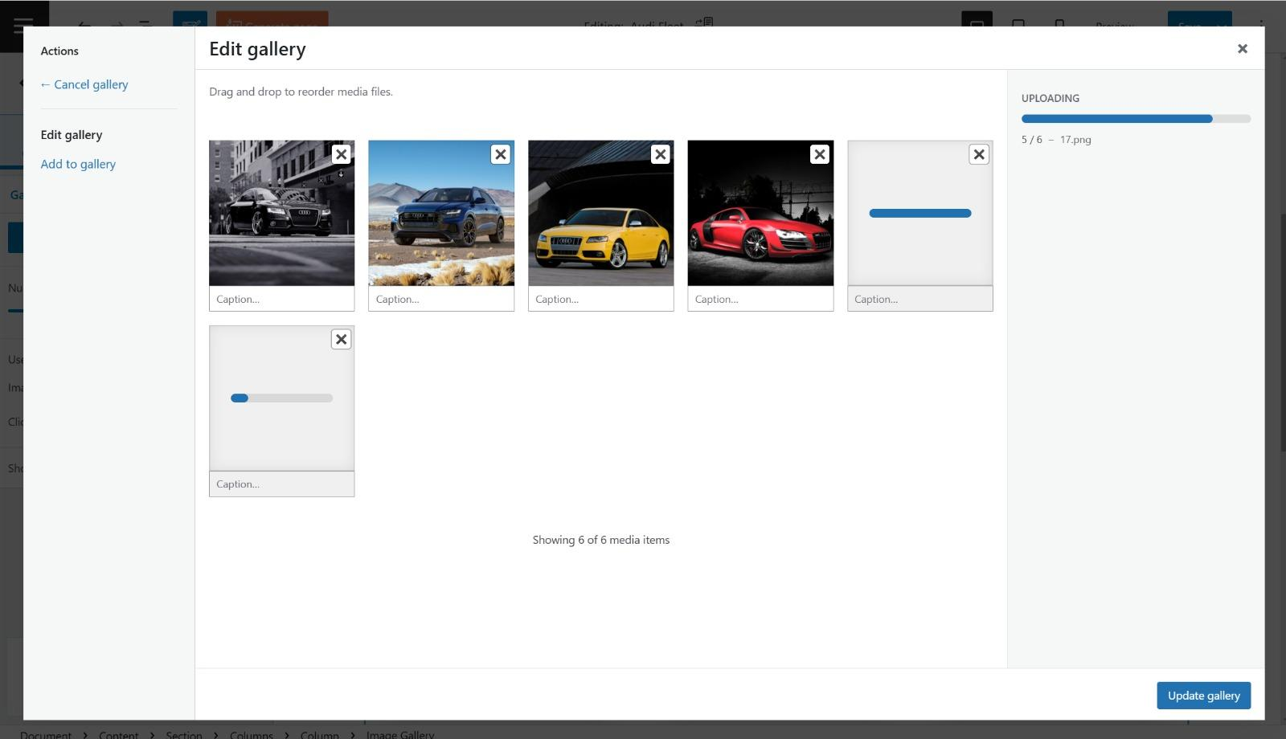
Adding gallery image to Audi fleet page with Kubio editor AI regenerate feature
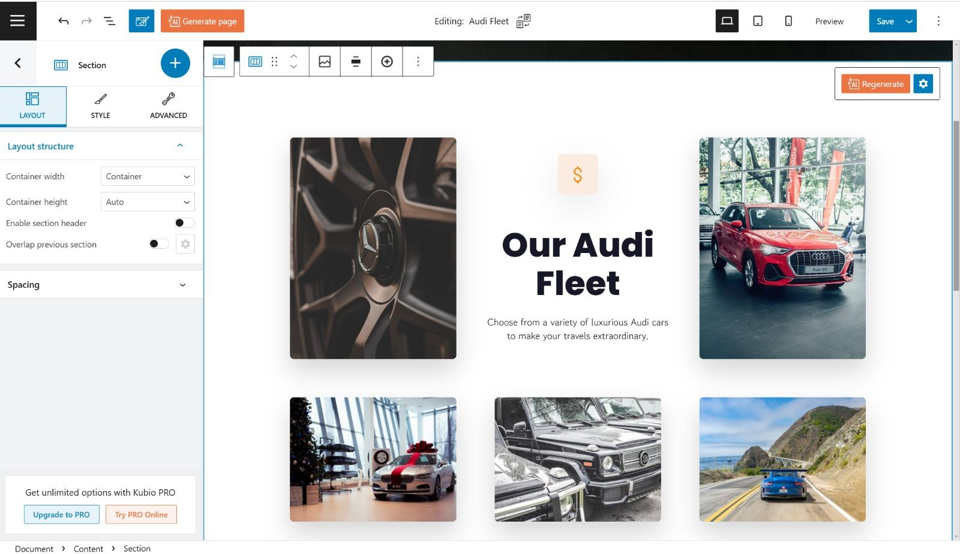
Editing layout to Audi fleet page with Kubio editor
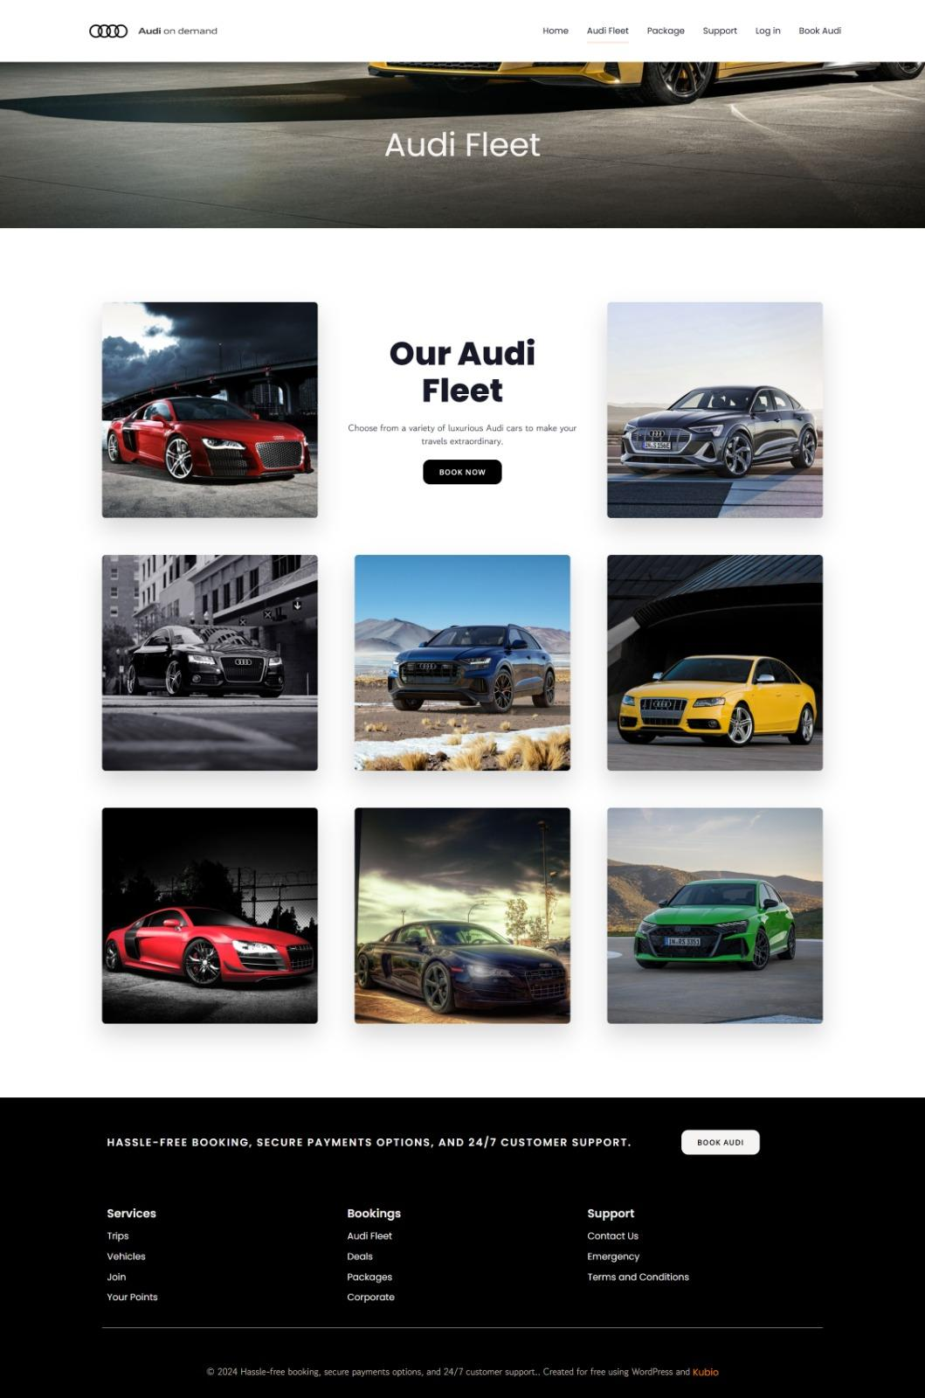
Audi fleet page complete view

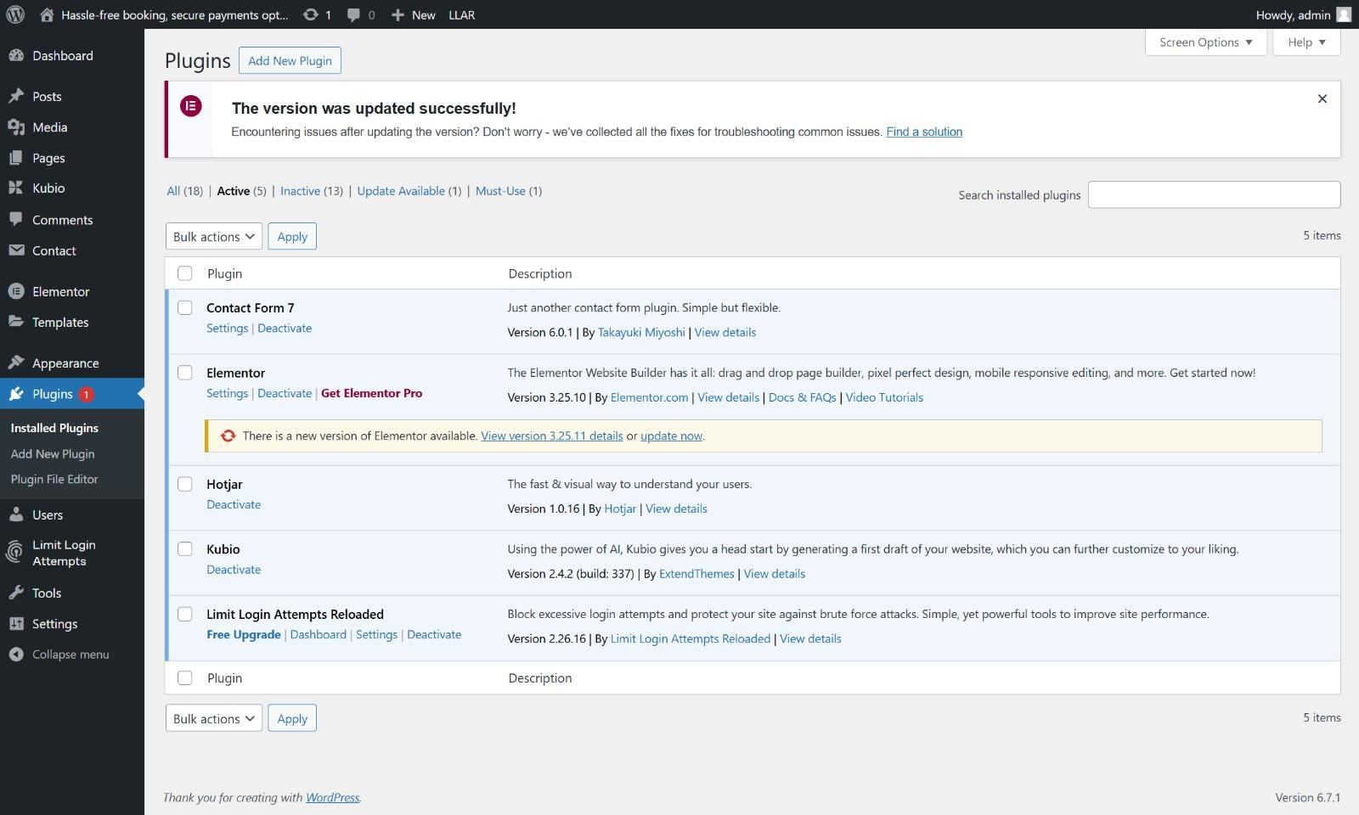
Active Installed Plugins and their features
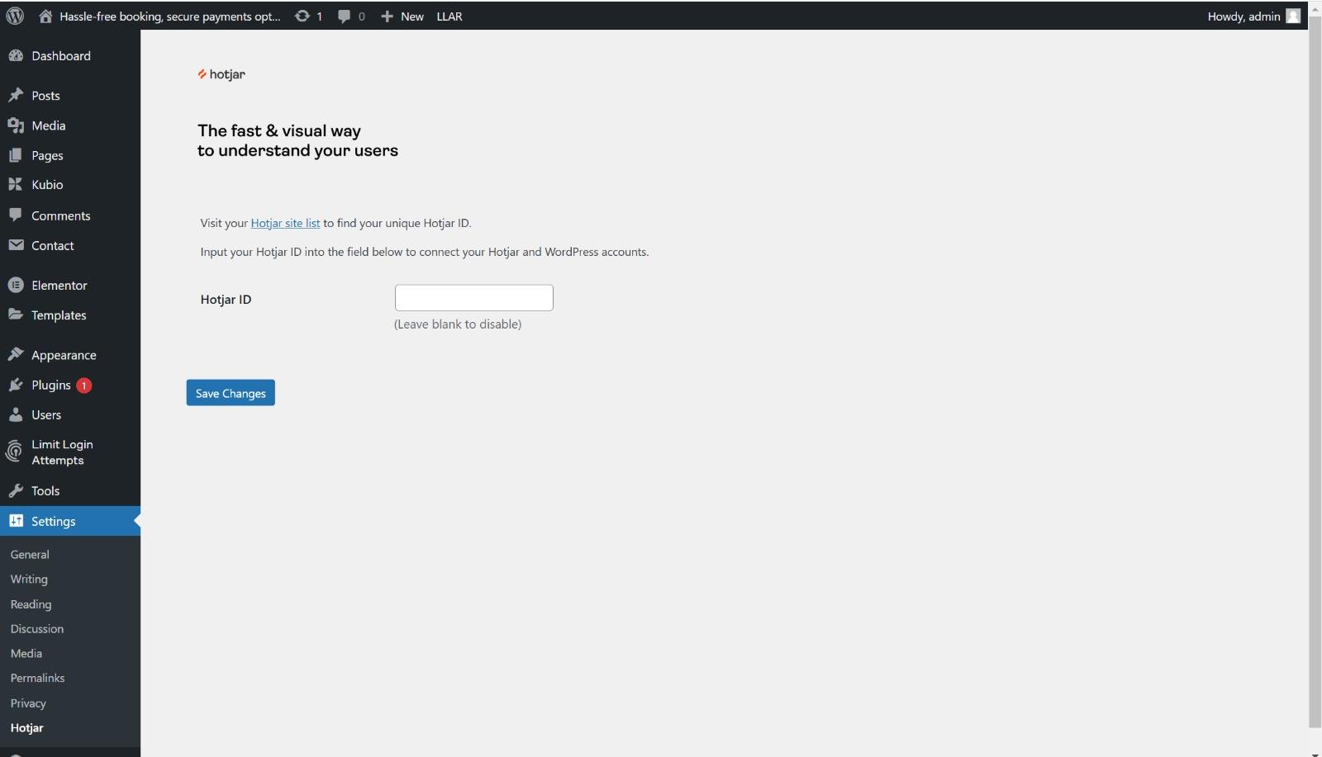
Hotjar setting page : We can connect our website to Hotjar dashboard with Hotjar ID from Hotjar account
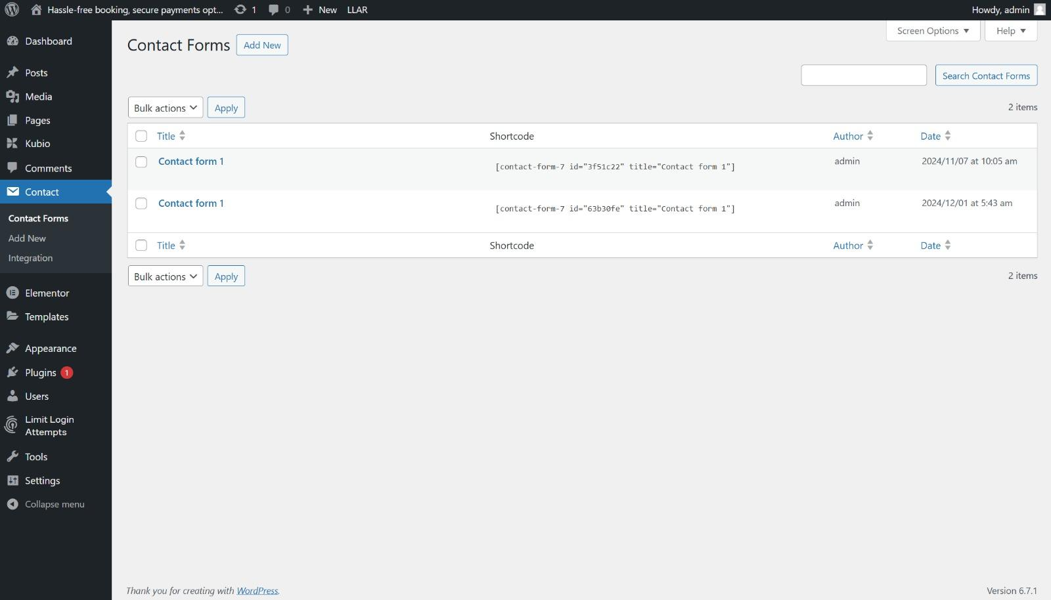
Installed Contact form Plugins
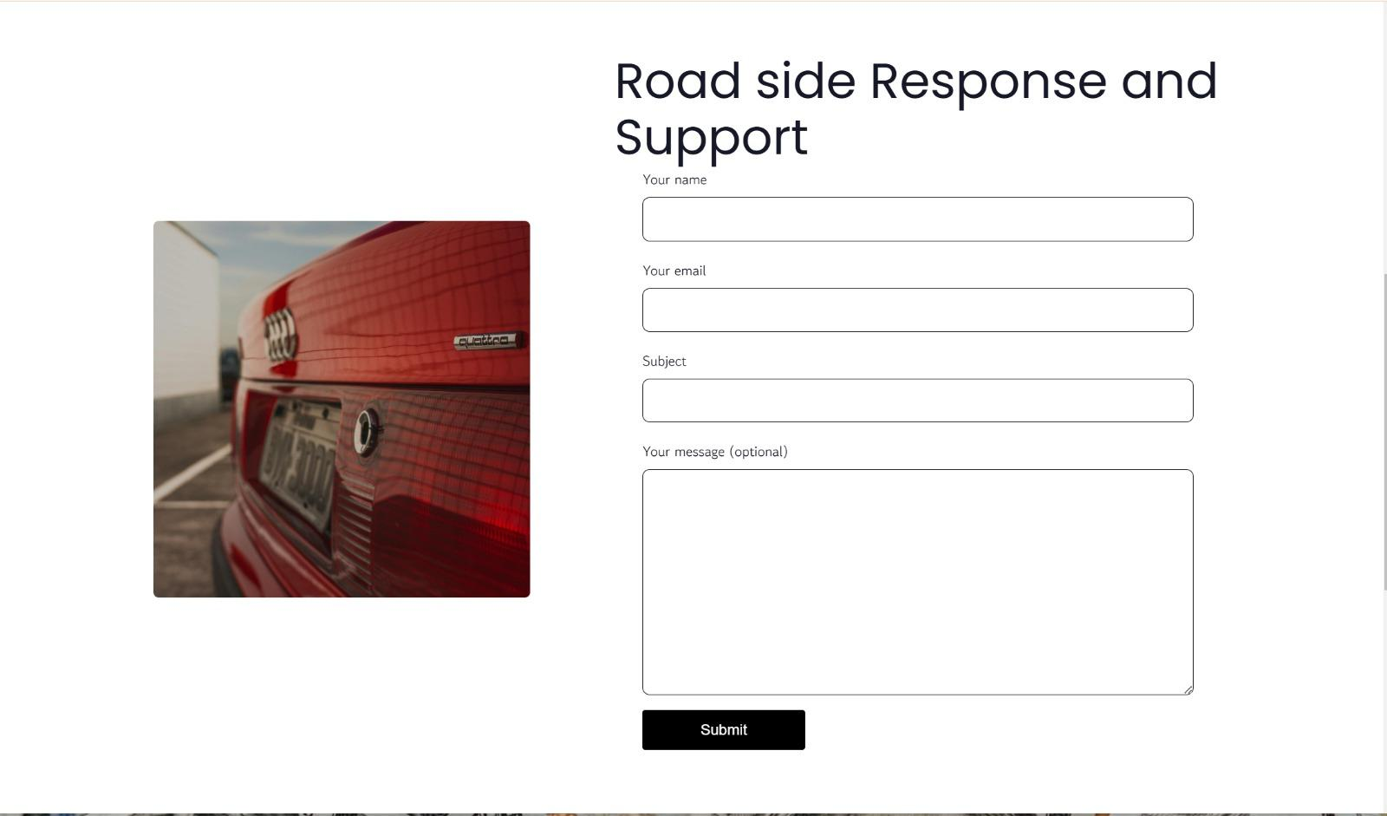
Contact form Plugins use on a page

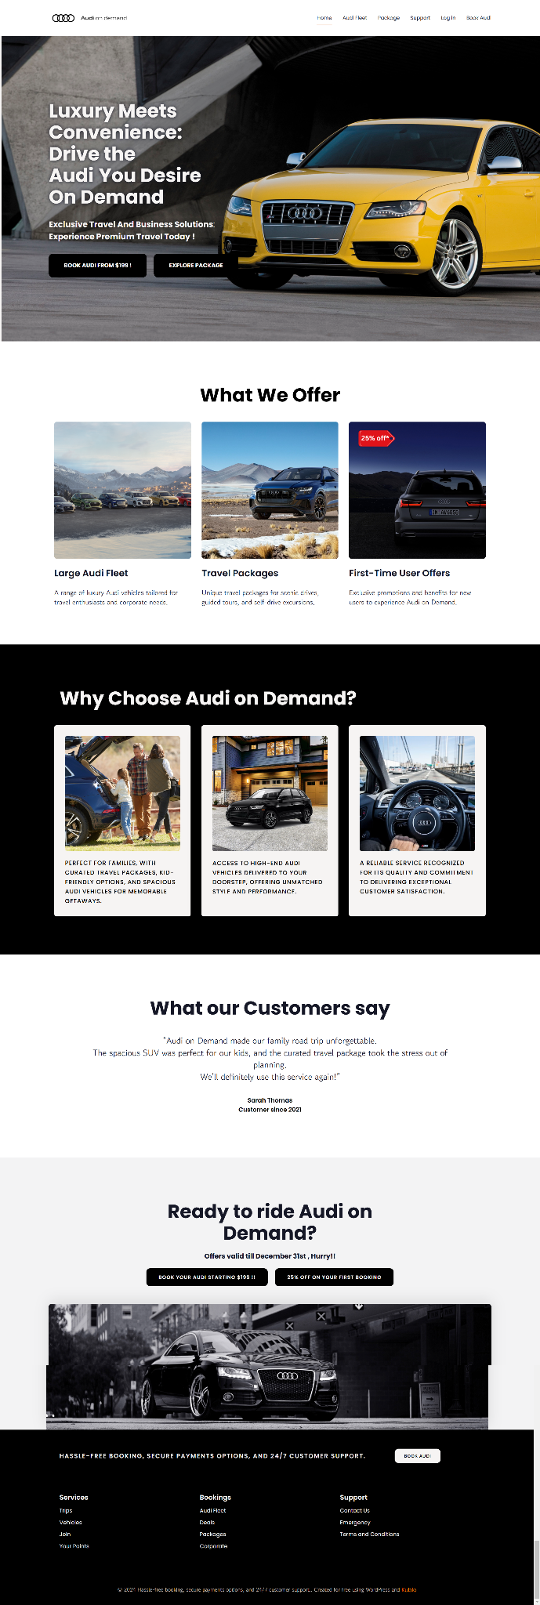
View of Complete Home page: https://design421.com/group2/

10. CONCLUSION

The Audi On Demand Travel Experience presents a transformative opportunity for Audi to expand its offerings into luxury travel while reinforcing its reputation for innovation, quality, and premium services. By aligning curated travel packages with Audi’s high-end vehicle fleet, this initiative enhances brand differentiation, drives new revenue streams, and deepens customer loyalty.
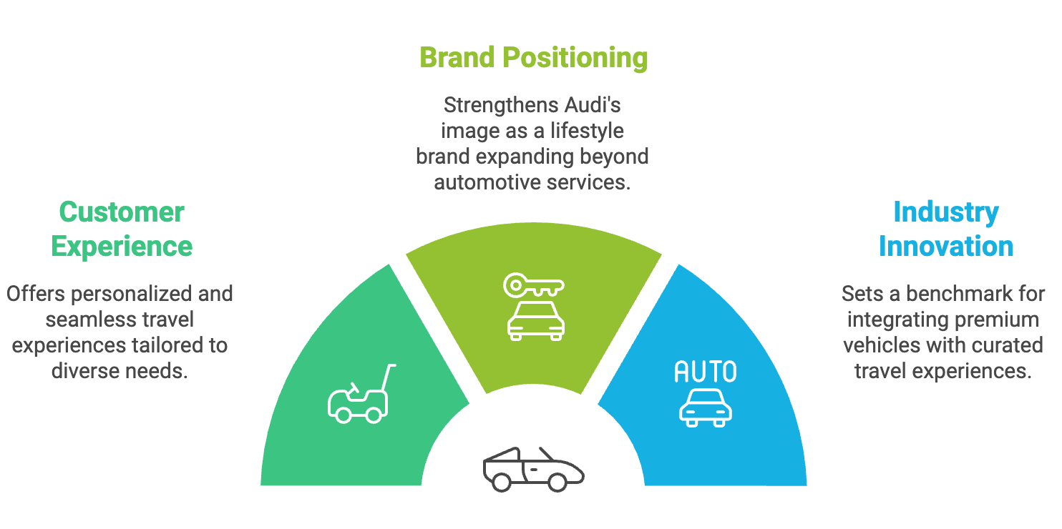
Fig 17: Key Outcomes: Redefining Luxury Travel with Audi

Impact:

For Customers: Offers a seamless, luxurious, and personalized travel experience tailored to various audience needs—be it adventure, family bonding, or sophisticated luxury.

For Audi: Strengthens its positioning as a lifestyle brand while expanding market reach beyond traditional automotive services.

For the Industry: Sets a benchmark for combining premium vehicles with curated experiences, driving innovation in the travel and automotive sectors.

With its carefully crafted strategies in marketing, financial planning, and customer engagement, the Audi On Demand Travel Experience positions Audi as the ultimate partner for redefining road trips into unforgettable luxury journeys.

11. APPENDICES
- Website/Online Article
McGlaughlin, F. (2022). The 8 Micro-Yeses Framework for Digital Success. MECLABS Institute. Retrieved November 30, 2024, from https://meclabs.com
- Kotler, P., & Keller, K. L. (2016). Marketing management (15th ed.). Pearson Education.
- Journal Article
Smith, J. R., & Brown, T. K. (2023). Luxury brand differentiation and consumer behavior. Journal of Marketing Trends, 21(4), 45-60. https://doi.org/10.1234/jmt.2023.0045
- News Article
Johnson, R. (2023, June 15). Audi launches new luxury travel platform. The New York Times. Retrieved from https://www.nytimes.com
- Company Website
Audi AG. (2024). Audi On Demand: Luxury fleet and curated travel packages. Retrieved from https://www.audiusa.com
- Blog Post
Travel + Leisure. (2023, December 1). Top 10 scenic drives in New York for luxury travelers. Retrieved from https://www.travelandleisure.com
- Report
Deloitte Insights. (2022). The future of luxury travel: Trends and insights. Deloitte LLP. Retrieved from https://www.deloitte.com
- Statistical Source
U.S. Travel Association. (2023). Travel trends report 2023: Post-pandemic recovery. Retrieved from https://www.ustravel.org

PRESENTATION SLIDES
